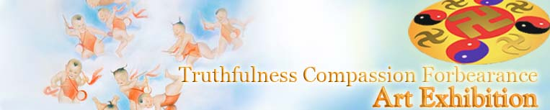

Truthfulness Compassion Forbearance
International Fine Art Exhibition

Descriptions of the artwork

www.falunart.org
Hurry up and Clarify the Facts
The Power of Art

[PureInsight.org] The Truthfulness, Compassion and Forbearance International Art Exhibit not only shows the beauty of Falun Dafa cultivation, but also discloses the truth of the brutal persecution that Jiang Zemin's regime inflicts on Falun Gong. At the same time, it inspires people with the universal principle of "Good is rewarded with good and evil is met with evil."

Righteous art can touch people's minds and hearts. Many people say, "It's shocking!" Others are moved to tears. Some practitioners have said that some issues are difficult to explain, and that during discussion, even when questions are clearly answered, people sometimes seem apathetic or disinterested. However, standing in front of the paintings, they immediately understand the message. This type of comprehensive visual information speaks deeply to peoples' minds, awakening their compassionate nature, and greatly shocking the factors that cause their apathy and lack of understanding. This exhibit is a deep and powerful expression of the Fa that completely denies the old forces' arrangements and makes it possible to fully expose the lies and deceit.

Most of the artwork was first shown on July 20 of this year in the Capitol Building in Washington DC. It was entitled "Uncompromising Courage," and was later exhibited in other countries. The exhibit has been very positively received in many South Korean cities, including Teagu, Seoul, and Suwon. For the first exhibit at Teagu, 50,000 brochures were printed to announce the exhibit. In Seoul, 100,000 brochures and 180,000 flyers were printed. As of December 2004, the exhibit has been shown in eight South Korean locations. South Korean practitioners are now preparing to publish all of the art pieces from the exhibit as a book, and publish this book in Chinese, English, and Korean languages. Many full sized copies of the art works have been sold throughout the county, exposing the Chinese Communist Party's deceptive propaganda and spreading the seeds of Truthfulness, Compassion and Tolerance.

Falun Dafa practitioners' art works were also exhibited at the annual National Book Show in Indonesia. Another exhibit for the Chinese community living in Indonesia is being planned.

The first show in Toronto was at York University, the most influential university in Ontario. Immediately thereafter, it was exhibited in London University Community Hall at West University of Ontario. In Ontario, there are exhibits almost every week. The next exhibit will be at the University of Toronto. Originally, the plan was to have two concurrent exhibits at two locations in the middle of October. Because an agent of Jiang's regime was working behind-the-scenes to intimidate the sponsors, only a small part of the artwork was shown at the National Art Club. This caused a great deal of attention from media and the community. The exhibition contract was for two weeks, but because of pressure from the media and the public, it was extended. Because of the popularity of the exhibit, growing numbers of people were attending. Near the end of the second extension, the National Art Club initiated an extension of the exhibit again, and also offered to provide their largest showroom to show the movie "Sandstorm," and slides of the other art works.

Many people expressed very positive comments regarding the exhibit. A history professor at a university in New York said, "Seeing China's figure skating entry win the world championship, I felt that the Chinese are very outstanding people. Now, after seeing the Falun Dafa exhibit, I feel the Chinese people are even more outstanding." The largest media group in Canada, CBC TV, gave a very positive report about the art exhibit during their prime time broadcast. After some people saw the exhibit, they immediately decided to learn about Falun Gong. Several in the audience even organized a Falun Dafa club.

Clarifying the truth with an art show containing this kind of cultural expression has a special power and appeal. Now that we have gathered a certain genre of artwork, additional and better pieces are constantly being added to the exhibit, and will be shown throughout the world. We hope more countries and communities will invite the Truthfulness, Compassion and Forbearance International Art exhibit to be shown, as it is a powerful expression of the Fa, presented through practitioners and their suffering.
For more information about the art show, send email to the editor, Zheng Jian: editor@zhengjian.org.

- Preparation Committee of the Truthfulness, Compassion and Tolerance International Art Show
Interview with Professor Zhang Kunlun

Reporter: Zhu Qingming, reporter for Zhengjian/PureInsight Net
Zhang: Professor Zhang Kunlun, painter and sculptor

Reporter: Professor Zhang, you are one of the organizers of this exhibit. Could you please tell us a little more about it?

Zhang: Falun Gong practitioners who are also artists have produced all the pieces exhibited here. Some of these are very accomplished artists. The subject matter of these works all relates to Falun Dafa.

There are two reasons for the exhibit. First, throughout their entire lives, these artists had searched for a pure and unblemished way to express themselves through their art but couldn’t find it. All the different schools of art in today’s society have been influenced by all kinds of notions and have hidden the artists’ pure, true selves. They were only able to recover their pure mindsets through Falun Gong practice. After they purified their minds, they have been able to free themselves of the influence of innumerable notions and found their true identities. Only then were they able to express the sides of themselves that are naturally good and kind. These pieces of artwork depict the wonders they’ve experienced in their cultivation and portray the experiences that they or other practitioners have endured during the vicious persecution of Falun Gong. At the same time, these works also show the steadfast spirit of Dafa practitioners in safeguarding the principles of the cosmos, as well as the sad endings of the evil forces as they are destroyed, which Dafa practitioners can foresee.

The exhibit is divided into four topics: harmony, adversity, courage, and justice. The persecution is groundless and unacceptable. Dafa practitioners have displayed immense moral courage during the persecution. The final part of the exhibit portrays how the evil forces will be tried in the court of public opinion and heavenly principles; that is bound to happen. Everyone is positioning himself. That is why Dafa disciples have been doing their utmost to clarify the truth. They are doing it not for themselves but for all living beings. Of course, that is a concept I can’t explain in just a few words.

Reporter: I believe those who see the exhibit will be quite affected by it. I’ve noticed that those who viewed this exhibit came from all over the world, and the exhibit has touched them greatly. Many of them have said that they want to help Dafa practitioners end the persecution as soon as possible. This exhibit is of tremendous significance.

Zhang: China’s historical records date back five thousand years. China has the longest continuously-run civilization in the world and its culture holds the envy of the world. Yet, China’s traditional culture has been on a downslide since the early 1900s and has been completely destroyed. After Jiang assumed power, the destruction has taken on unprecedented heights. Under Jiang’s dictatorship, ancient Chinese culture and human rights has become a taboo subject and human dignity is disregarded. Jiang lives only for political power and personal wealth.

Jiang banned Falun Gong, which advocates the time-honored Chinese tradition that teaches people to be righteous and kindhearted. It had gained popularity because of its physical and mental health benefits. Cultivators of Falun Gong were found to be free of illness, even incurable illnesses, within a very short time of beginning this practice. They found well-being and life without medical and mental problems.

Delinquent, incorrigible and maladjusted youth turned to goodness after practicing Falun Gong. They were able to find the true meaning of life. It was found that this practice did not require advertising or propaganda to spread among the populace. It was spread by word of mouth, from person to person in China. Within only a few years, more than a hundred million people practiced it. Therefore, given ordinary people’s concepts and notions, a nation’s leaders should be thrilled about such prospects. The nation has achieved a highly moral culture. Isn’t that great? Yet, because of jealousy, Jiang began to suppress and ban Falun Gong!

Jiang assumed power because of the "June 4" Tiananmen massacre. His political power is based on the suppression of others. His "achievements" are stained with red blood. The "Red Wall" is the symbol of Jiang’s dictatorship. If truth were told, the red color is considered favorably in the minds of Chinese people.

In this painting, the red color is gruesome and terrifying. The wall looks very oppressive. But there are many cracks in the foundation and at the top, and it is about to crumble. It depicts a dictatorship that cannot be sustained. During Jiang’s reign, Dafa practitioners suffered enormous hardships. But, their spirit has risen above and beyond, because they are selfless, and live by the universal truth. They are performing a great and compassionate deed and the outcome will be glorious!

Look at the Falun Gong practitioner who suffers because of the persecution, his primordial spirit has risen above and beyond. He is I! I was arrested four times in China, beaten up, and shocked with electric batons. My house was ransacked. I was detained in prison and unlawfully sentenced to forced labor. Then, after being released, there was nowhere in China where I could speak the truth. China is virtually a gigantic prison! My every move and action was watched and I could be arrested any time without cause. In the public opinion of the world, there was no reason why the Chinese government could not release me. Even after I was released, I was still not given my freedom. This painting reflects my feelings and plight at that moment in time.

Being shocked with an electric baton is a terrible experience, and a very painful one. I was shocked with two electric batons at the same time. Then, I was sentenced to forced labor. An incident that sticks in my mind forever happened the day I was sent to that forced labor camp. The police discovered a Falun Gong practitioner performing the exercises. That practitioner was beaten close to death’s door. Twenty-eight practitioners could not accept this cruelty and told the police to stop violating human rights. The police ignored them. The twenty-eight practitioners went on a hunger strike to impress upon the police that they were in the wrong. The police responded in a violent manner, without restraint. They dragged practitioners outside and beat them severely. Many of them were seriously injured.

After my arrival at the forced labor camp, I was taking a bath. I noticed many practitioners with extensive injuries and coagulated blood all over their bodies. Don’t they know that such tortures will not change people’s deeply held belief in the truth? Subsequently, I was transferred to another forced labor camp.

At that camp, the staff members were very deceitful in trapping and misleading prisoners. Special agents were planted who spread lies to confuse the minds of practitioners. The intent was to bamboozle them. Because the practitioners had been confined for a long time they had lost touch with other practitioners. Therefore, the authorities had special agents pretend to be Falun Gong practitioners. They spread rumors and fabricated information to confuse the practitioners. Falun Gong practitioners were brainwashed and deceived under such conditions.

At that location, a practitioner told me that when he went to appeal for the first time, police beat him to near blindness. When the police thought that they had killed him, they took him to Shijiazhuang, a distant place, where they dropped him. He recovered there. He decided that he must tell the truth and appeal to the government. He thought he had to make the government understand about the wrongness they perpetrated. So he returned to Beijing and was arrested again. This time, the police put sand on the bottom of their shoes and rubbed them against his buttocks until no more skin was left on his buttocks. The pain was beyond words. When telling me his experience, his body was shaking and tears flowed from his eyes.

An elderly man, a former teacher, was held at the same forced labor camp. Because he refused to renounce the practice, he was confined in a steel cage. His arms were tied in a position identical to that shown in the painting. He was unable to move. Then the police ordered a depraved prisoner to hold a poisonous snake to his neck. The snake bit him. The fang broke and remained stuck in his neck. The elderly man dug the fang out. He was a practitioner and was immune to the poison. That was extraordinary. If he were an ordinary person, without a doubt he would have died. I remember many similar incidences. My friend and a student's parent witnessed this incident. Jiang disregarded such occurrences, ignoring the benefits to the Chinese people. What is depicted in this painting is the terror created by the dictator Jiang’s suppression.

Jiang gave the directive on how to deal with Falun Gong practitioners, "bankrupt them economically, ruin their reputations, and physically exterminate them." I believe that you can see in your mind how Jiang utilized the national machinery, including the educational and legal system, military, special agencies, and all levels of government, from the top to the bottom to perpetrate the persecution. Any student who practices Falun Gong or supports Falun Gong is deprived of an education. The government-owned media, television, and radio broadcasting, foreign affairs departments, and many others serve a role in the persecution. Jiang used more than one-quarter of the national budget to suppress Falun Gong. This tells you of the extreme magnitude of the suppression. The persecution methods combine the persecution methods used in the past and present worldwide. There are alone more than hundred torture methods. You can imagine how ruthless, cruel and savage that is!
The Beauty of Cultivation

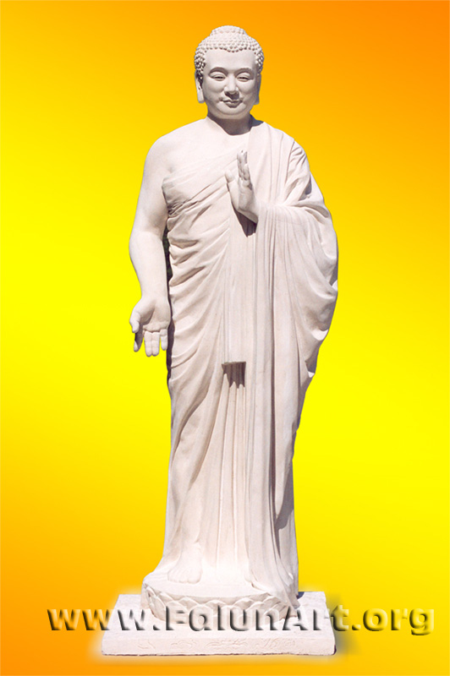
Buddha
By Kunlun Zhang
Sculpture - Height 51 in - 2004

[Falunart.org] The artist made this sculpture in the image of the Buddha whom he reveres.

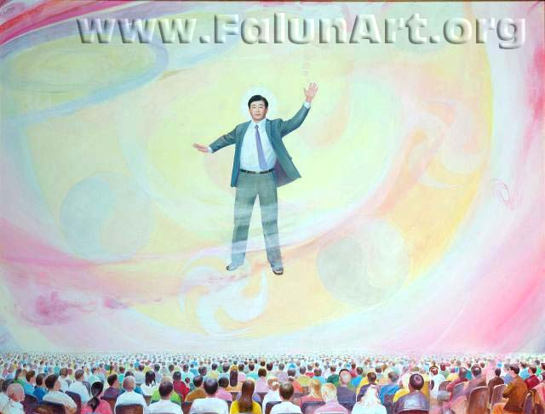
Turning the Great Law Wheel
By Kunlun Zhang
Oil on Canvas - 82.5 in x 63 in - 2004

[Falunart.org] This painting depicts the founder of Falun Gong, Mr. Li Hongzhi, before an audience as he Turns the Great Falun. "Falun" literally means Law Wheel, a term from Buddhist traditions. One of the meanings of the phrase "Turning the Great Law Wheel" is the actual act of teaching of the Great Law of the Universe.

Guide: (For Practitioners:) This painting depicts the founder of Falun Gong, Master Li Hongzhi, before an audience at the 2003 Fa Conference in Washington D.C. According to disciples whose Celestial Eyes are open, Master Li sent out layers after layers of Faluns to bestow wondrous things to the more than 5,000 disciples who attended the conference. Each disciple received different things based on his own individual conditions. Master Li’s body in other dimensions was incomparably tall. He sent out numerous energy currents in the color of red, which filled the entire meeting hall. Numerous large and small Faluns rotated inside the bones and internal organs of disciples who were at the conference. The scene was incomparably magical.

(For audience:) This picture was inspired by an event at an experience sharing conference. Practitioners hold conferences coming together to share their experiences of being on the path of cultivation. Sharing understanding they have enlightened to, attachments they recognized and let go of, hardships they have overcome and insights in clarifying the truth about the persecution. The conferences are always open to the public so they are also a way people can learn about us through the experiences of those who practice. In this work, the Teacher and Fonder Mr. Li Hongzhi stands on stage before the audience doing a hand motion called turning the great Falun (Law wheel or Principle wheel). Through the practice of self-refinement (cultivation) with the improvement of your heart, moral, mind nature. By assimilating to principles Truthfulness (Purity), Compassion (Kindness) and Forbearance (Giving, Self control), virtue increases, a form of light, high-energy mater. This energy is cultivated (Grown) as one increases virtue. By combining the exercises with the raising of virtue, one's body becomes filled with high-energy matter. This has been confirmed in scientific studies that can measure energy. And it's been known for a long time that qigong masters and monks have this cultivation energy called Gong. This energy can awaken one's natural inborn abilities like the third eye. This is quite common in the practice Falun Gong, for those with few attachments and pure intentions to have these abilities opened. Those who can see other dimensions with the third eye described this swirling energy to the artist as seen in this picture. Those who couldn't see it could feel a wonderful positive feeling.

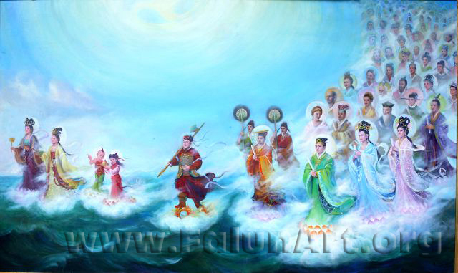
Fulfilling Vows
By Xiaoping Chen, Xiqiang Dong, & Ru yi
Oil on Canvas - 79 in x 47 in - 2003

[Falunart.org] The heavenly beings in this painting represent all races and cultures. There are practitioners of spiritual practice of Falun Gong in over 60 countries around the world. Its practitioners represent every ethnic group and every walk of life. Although Falun Gong originated in China, the search for truth and enlightenment is universal.

[PureInsight.org] The heavenly beings of different divine races and cultures in this painting are on their way to descend to the human realm in order to fulfill their vows to assist the Lord Buddha with the Fa-rectification. A giant Falun is rotating above the heavenly beings. Their faces are registered with solemnity and peacefulness for they know they are going to fulfill their grand pledges to assist the Lord Buddha with the unprecedented Fa-rectification.

Guide: This painting has both eastern and western technique with more than one artist taking part in its creation. The beautiful gowns with their translucent colors have an other worldly quality. Riding on lotus flowers coming in on a wave, they are all very different but with at least a few things in common: heavenly courage, a heart for others, and vows to be fulfilled.This work was inspired by an ancient legend. All these beings came from many different heavenly paradises where everything is splendid and wonderful, but they still made vows to come here, having their minds wiped, not even knowing who they where anymore, to a place of suffering and delusion, with a chance of never finding their way home. What kind of heavenly courage would it take? This question inspired the painter. The mission they vowed: to come here to help save sentient being and to (rectify the cosmos), to put things right.

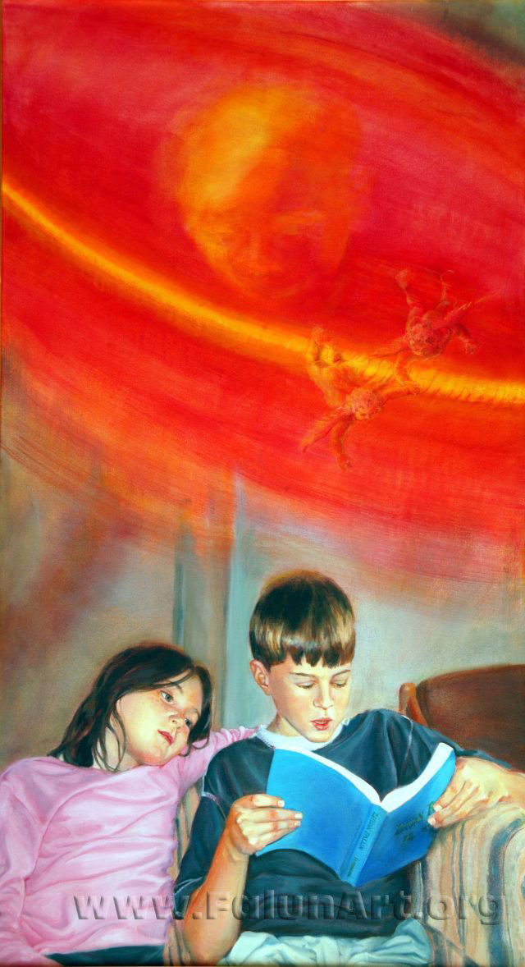
Assimilation
By Kathy Gillis
Oil on Canvas - 32 in x 57.5 in - 2004

[Falunart.org] The brother and sister in this painting are reading Zhuan Falun, the main book of the Falun Dafa teachings. The spinning, red light above is an expression of the book's enriching teachings. The book has been translated into more than twenty languages.

Guide: The artist wanted to create a painting with a homey feeling that appeals to western audience. There are two main elements in this painting: the red fog and the artist´s grandchildren. She once saw a photograph of a Falun Gong practitioner reading Zhuan Falun in public. In the photograph, she saw a red fog above his head. When her husband saw the photograph, he exclaimed, “Look at the face in the fog!” she was amazed by the miraculous moment captured by the camera. So she decided to incorporate the red fog with a face into the home portrait of two children reading Zhuan Falun. Later a Celestial vision explained that the rotating red fog was actually a group of multiple Falun’s spinning in circles. The rotating Faluns in a snapshot resembles a red fog. The face turned out to be a high-level being in cultivation. The two children in the painting are the artist grandson and her granddaughter.

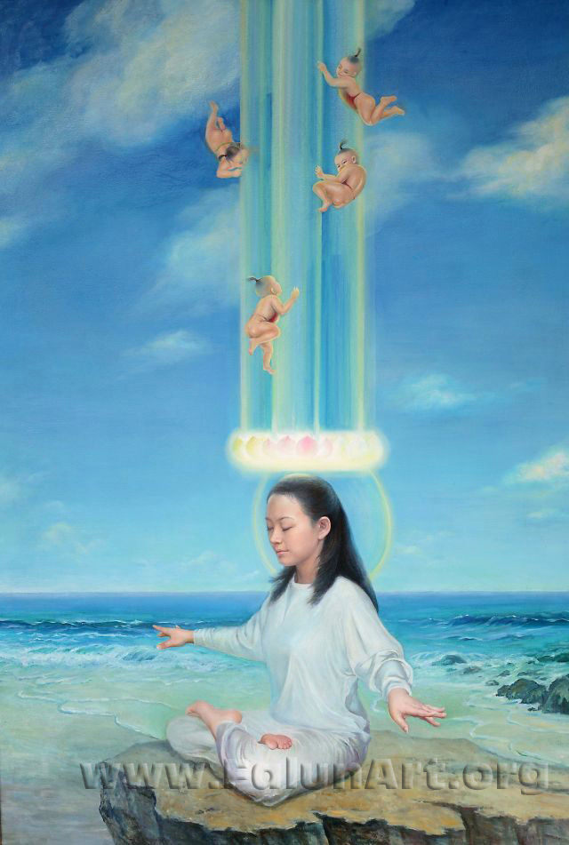
In Harmony
By Xiaoping Chen
Oil on Canvas - 47 in x 69 in - 2004

[Falunart.org] This painting depicts a young woman doing the fifth exercise of Falun Gong, "Way of Strengthening Divine Powers." The clear water and blue sky reflect her tranquility and give a feeling of her union with heaven while she meditates. The four "cultivated infants " play amidst an energy field.

Guide: This is a self-portrait of the artist. She said she painted this to share a wonderful experience she had wile practicing Falun Gong´s fifth exercise sitting meditation. Falun Gong is cultivation practice. Cultivation is to nurture one´s nature and return to purity, also known as self-refinement. The method is to raise ones attainment level, improving your heart, moral, mind nature by vigorously striving to assimilate to what we believe to be the highest cosmic characteristics: Truthfulness (purity) Compassion (kindness) Forbearance (giving). This process of improving one´s character is by giving up bad attachments, desires and dissolving karma, gradually attaining a clear mind and pure heart, which can enable one to reach a state of tranquility thus connecting with our true nature, this highest cosmic characteristic to be True, Good and Endure. In harmony with the earth and the universe as in this painting, she blends with the earth as seen in her blurred outline

One hand points out to the ocean, the other to the viewer, to draw you into the painting with her as she connects to the universe. The energy above her head is commonly known in eastern cultivation practices as three flowers rotating above the head. This is just one of the many different states that can be reached in cultivation, as everyone has their own unique path. The four babies playfully celebrating her achievement are called ying hei (Chinese cherubs); instead of angle wings they have these cute bathing suits. The three boys in red could represent Truthfulness, Compassion, Forbearance and the little girl repeat, Truthfulness, Compassion, Forbearance / Repeat - showing the cultivation method of constantly refining oneself, within these principles.

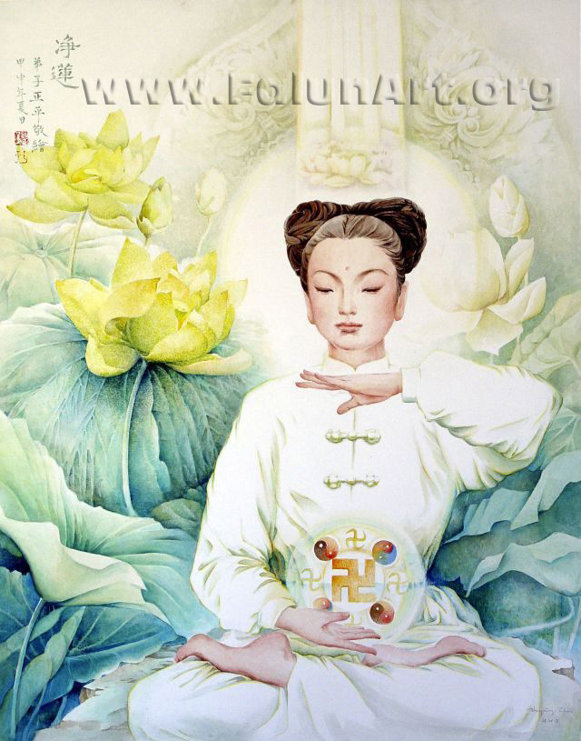
Pure Lotus
By Zhengping Chen
Chinese Painting - 29 in x 37 in - 2004

[Falunart.org]The woman in this painting practices the sitting meditation, the fifth exercise of Falun Gong. Lotus flowers blooming around her indicate the purifying effect of the meditation on both mind and body.

Guide: Pure Lotus is painted with a combination of traditional Chinese painting and watercolor in the western tradition. The artist said she chose to combine these two traditions because she believes the traditional arts are gifts of the Divine, their realm of expression is high, and they can help lead people toward enlightenment of their spirits
When asked what her inspiration for this piece was she said,
-As a Falun Gong practitioner, her first thought was how could she possibly carry to people the idea of wonderment of cultivation and the transcendence that we who practice, may experience. Falun Dafa cultivates both the mind and body, and doing meditation can allow one to enter into a state of deep tranquility and a moment that is solemn and sacred. She wanted to express this quality, this transcendental experience that Falun Gong can bring.
She expresses the purity of this experience.

In this painting, the "Lotus Flower," a maiden sits in meditation. She gives one the impression of pure serenity, free of all mundane or worldly elements. Her hair is pinned up high to show the height her mind has reached. In the background are the lotus flowers, which also gives an otherworldly impression. The lotus is the symbol of purity and also the flower of the Buddha's paradise. In traditional Chinese culture the lotus shows the predestined relationship with the Buddha, and it is used as a symbol of one's attainment status, that is, how high one's spirit has ascended. The pure maiden sits in front of the lotus that is the totally pure, not touched by this world.

Uncompromising Courage

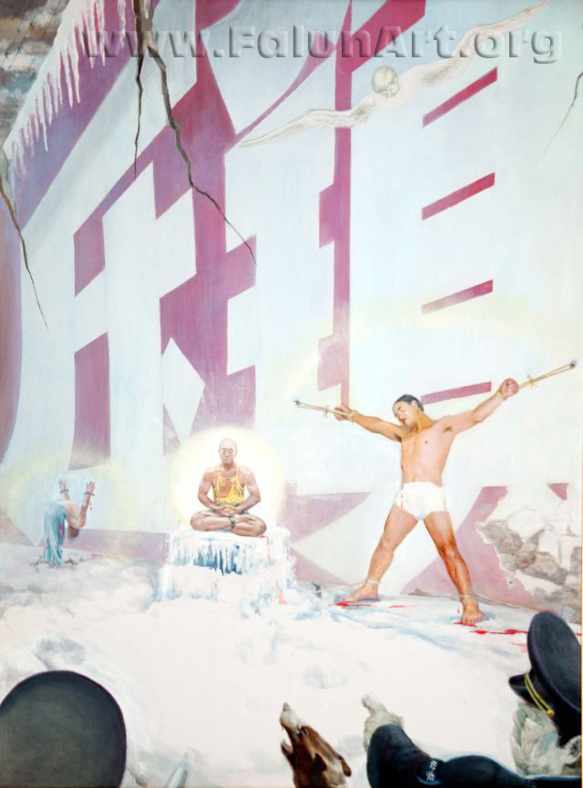
Red Wall
By Kunlun Zhang
Oil on Canvas - 36 in x 48 in - 2004

[Falunart.org] This work records the personal experience and internal turmoil of the artist, Professor Kunlun Zhang. Professor Zhang was imprisoned in China for three months, during which time he experienced physical and mental torture, including brainwashing. The two white Chinese characters (meaning persecution) on the red wall represent the persecution of Falun Gong in China, which is so oppressive that it makes China seem like one big prison. The crack in the wall indicates that despite the red wall's menace and seeming invincibility, its collapse has already begun.

[Pureinsight.org] Look at the Falun Gong practitioner who suffers because of the persecution, his primordial spirit has risen above and beyond. He is I! I was arrested four times in China, beaten up, and shocked with electric batons. My house was ransacked. I was detained in prison and unlawfully sentenced to forced labor. Then, after being released, there was nowhere in China where I could speak the truth. China is virtually a gigantic prison! My every move and action was watched and I could be arrested any time without cause. In the public opinion of the world, there was no reason why the Chinese government could not release me. Even after I was released, I was still not given my freedom. This painting reflects my feelings and plight at that moment in time.

Guide: The artist Processor Kunlun Zhang is listed as one of top sculptures of the world. He was freed by practitioner´s efforts, support from public letter campaigns, the Canadian government and Amnesty international. Being so highly recognized the authorities thought they could hurt him the most by destroying his reputation. So besides the physically torture they secretly filmed him editing it together then broadcasting it on national TV for him to watch. They used any and all means to try brake his spirit. But on the contrary seeing the other practitioners enduring what a seemed in possible to endure he knew it was there faith that gave them the courage and strength to hold true and his faith grew ever stronger.

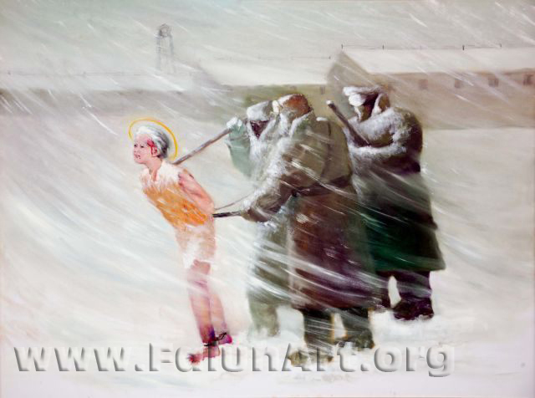
Unwavering Spirit
By Chongqi Yao
Oil on Canvas - 48 in x 36 in - 2004

[Falunart.org] This painting is based on a true story as captured by Ian Johnson, a reporter from The Wall Street Journal. In the article, he wrote, "The day before Chen Zixiu died, her captors again demanded that she renounce her faith in Falun Dafa. Barely conscious after repeated jolts from a cattle prod, the 58-year-old stubbornly shook her head. Enraged, the local officials ordered Ms. Chen to run barefoot in the snow. Two days of torture had left her legs bruised and her short black hair matted with pus and blood, said cellmates and other prisoners who witnessed the incident. She crawled outside, vomited and collapsed. She never regained consciousness, and died on Feb. 21."

Guide: In this work you see three guards push and prod with electric batons a 58 years old practitioner through the blistering cold elements. The woman is walking with her head held high and with a determined look in her eyes, unwilling to betray her conscience.

The Path: ”Cultivation is hard. It´s hard in that even when a terrible calamity strikes, even when evil madly persecutes, and even when your life is at stake, you have to be able to steadfastly continue on your path of cultivation without letting anything in human society interfere with the steps you take on your path of cultivation.”
Mr Li Hongzhi

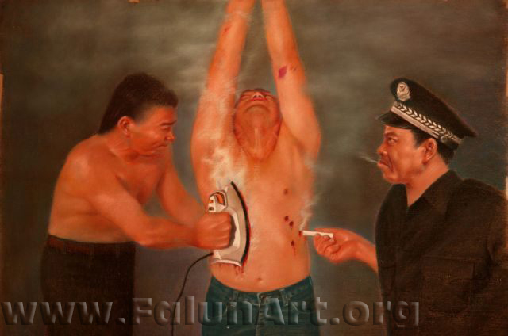
Smoke and Ash
By Zhiping Wang
Pastel on Paper - 39 in x 27.5 in - 2004

[Falunart.org] Besides an iron and cigarettes, prison guards have been known to use hot iron pokers that burn all the way to the bone on people who practice Falun Gong. Jiang Zemin, the former leader of China who is responsible for the persecution of Falun Gong has decreed that "no means are too excessive" to eliminate the practice.

Guide: The artist wanted to portray the force and cruel taunting nature of the wicked police This is expressed with one torturer having removed his shirt from the exertions of putting all his efforts in torturing this practitioner of Falun Gong. The force in which he inflicts this burn is shown in his bulging veins. Also the expressions on the police with the cigarette, revels some even take seek pleasure in torturing these innocent people.

This painting vividly portrays the torture “Human Grill” --- one of the many horrible tortures that the torturers in the torture chambers in China’s police stations, forced labor camps, and forced brainwashing centers mostly commonly use on Falun Gong practitioners who refuse to give up their belief in Falun Gong.
This is an extremely vicious and cruel type of torture. The Chinese police have used cigarettes to burn many Falun Gong practitioners’ faces and created horrible black burn scars on their faces. Some extremely cruel police officers have burned and ruined the faces of some young beautiful female Falun Gong practitioners.

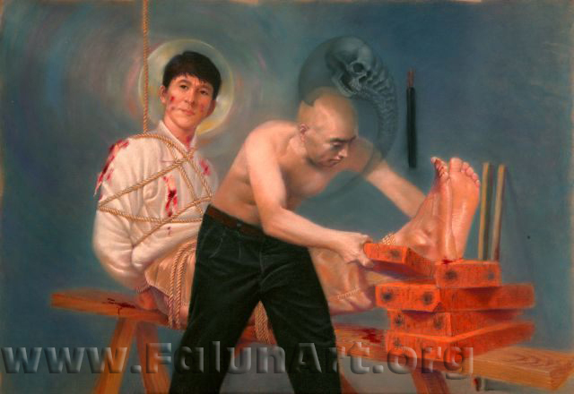
Tiger Bench
By Zhiping Wang
Pastel on Paper - 39 in x 27.5 in - 2004

[Falunart.org] This piece depicts a common torture method used to inflict severe, prolonged pain. Bricks are stacked beneath the feet while ropes tying the legs down are pulled tight, bringing the legs to the point of breaking. The artist has given both men an ethereal halo - one bright, one dark and ghostly. The stark difference suggests what might be awaiting both men after this lifetime based on the choices they have made.

Guide: The detail in this pastel is exquisite, as can be seen in the warm glow of the practitioners' skin. Practitioners in these places constantly clarify the truth about the persecution by letting all, including their torturers, know they are good people wrongfully persecuted, and ask them to not follow, for their own sake, what they are ordered to do. The two halos represent what awaits them in the future. One is light, spreading out in many colors. The other is dark, with sculls getting smaller proceeding all the way to non- existence. The meaning the artist is expressing here is that the amount of karma this man would get will cause his suffering and disintegration layer by layer all the way down. Retribution for what he does, in this deed of harming a person who is kind and selfless, on the path of cultivation. In this way the artist expresses the principle "You do good, you will get good. You do bad, you will get bad." There's a serene expression on the practitioners face connected to his heart of compassion. The strength of courage is seen in the depth of his eyes. He will not yield!

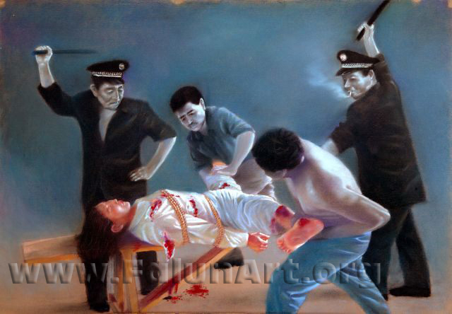
Torture of a Woman
By Zhiping Wang
Pastel on Paper - 39 in x 27.5 in - 2004

[Falunart.org] Accounts by female prisoners of conscience who have lived through torture in Chinese detention centers detail horrendous physical and sexual torture by not only prison guards, but prison inmates as well. It has been reported that some women who practice Falun Gong have been stripped naked and locked into male prison cells.

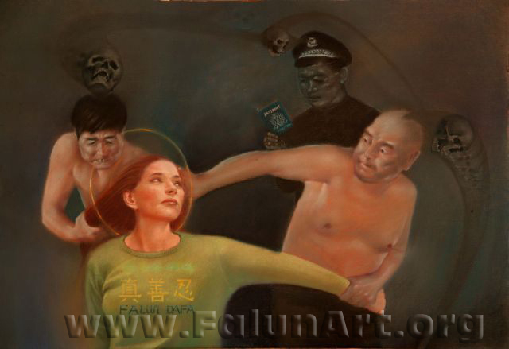
Abuse
By Zhiping Wang
Pastel on Paper - 37 in x 25.5 in - 2004

[Falunart.org] The scene in this painting is based on a true story about an American Falun Gong practitioner who traveled to China to appeal to the Chinese government to stop its persecution of Falun Gong. She was arrested, physically abused by police, and then was expelled from China.

Guide: The artist has expressed the inner spirit of those in this painting. The wicked police having sculls representing ghosts from hell. And the practitioner with the circle of light expressing her saintly continence sacrificing herself to save others. The scene in this painting is based on a true story: On November 20, 2001, around 2 p.m., a group westerners from all over the world gathered at Tiananmen Square in Beijing, China. They sat in the meditation position, unfurled a large yellow banner emblazoned with the words, “Truth, Benevolence, Forbearance,” shut their eyes, and began their Falun Gong meditation exercise.
Within seconds, Chinese police vans rushed over and surrounded the group, and officers began forcing the foreigners inside. In response, they started to shout in Chinese: “Falun Gong is good!” Their actions were peaceful and in complete compliance with the fundamental rights spelled out in the Universal Declaration of Human Rights.
However, all of these practitioners were arrested, mistreated, and forcibly deported by Chinese police. Many of them were beaten, some severely. While in police detention, these people were not allowed contact with their families, not allowed legal representation, and not even allowed contact with their embassies. They were interrogated, intimidated, and most of them had their valuable belongings stolen by the police.

The mistreatment and physical abuse of western Falun Gong practitioners by the Chinese police only serves to expose the Chinese Communist government’s lies that their police refrain from using violence against domestic Falun Gong practitioners. If the Chinese policemen have no scruples to inhibit them from beating these foreigners, knowing that the victims are to be deported within hours, what would they not do to Chinese Falun Gong practitioners who they can incarcerate indefinitely.

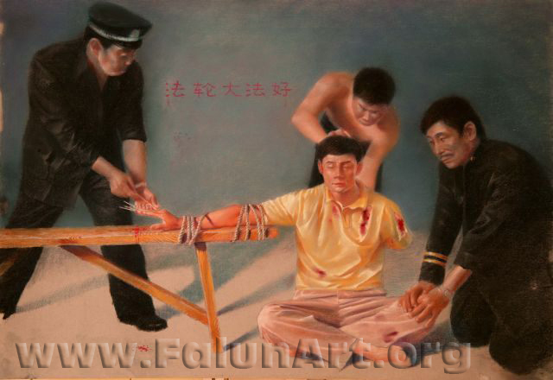
Like a Stone
By Zhiping Wang
Pastel on Paper - 39 in x 27.5 in - 2004

[Falunart.org] With this torture method, sharp bamboo sticks are jammed underneath the fingernails. This method has been used on Falun Gong practitioners. In this depiction, even though the pain is excruciating, the practitioner endures.

Guide: Written on the wall in the background is “Falun Dafa is Good”. This is very significant in that Dafa means the Great Way, an expression from old Chinese culture to improve ones heart to cultivate to go back to goodness. In China, where atheism is now imposed, these beliefs are said to be bad.
One arm twisted behind his back, the other tied down and bamboo shoots are shoved under the fingernails. How does he remain serene without fighting back or screaming out? The Truth that he has done nothing wrong gives him courage, the Compassion that fills his heart keeps him out of self, and Forbearance gives him the inner strength to endure.
His unmoved expression seems to be affecting a change in the policeman in front as he looks on.

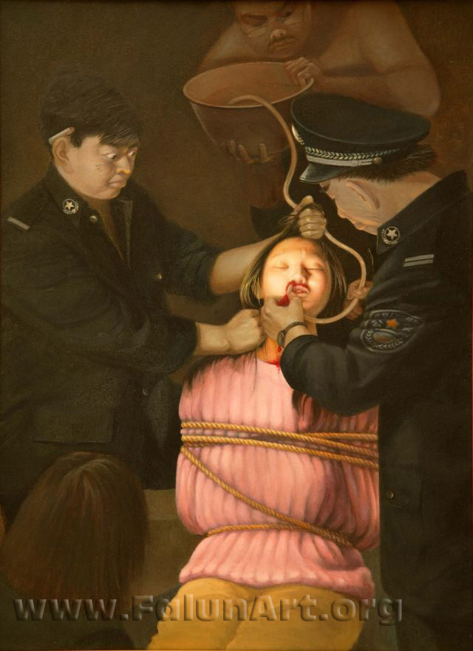
Force Feeding
By Weixing Wang
Oil on Canvas - 22 in x 30 in - 2004

[Falunart.org] Once in jail and subjected to brutal torture, brainwashing and forced labor, Falun Gong practitioners have no means of appeal other than a hunger strike. Prison guards often use force-feeding as a form of torture. During force feedings, the guards hold down the victim and pry open the mouth with metal clamps. They then force a course rubber tube down the esophagus or insert a tube through the nostrils. They pour in substances such as a mixture of water and cornmeal, concentrated salt solutions, hot chili paste and even human excretory waste. The intention is to inflict pain so as to break the will. Such torture is extremely painful and is the most common cause of death.

Guide: In this painting the light emanates from the practitioner, a bright light in this dark place.

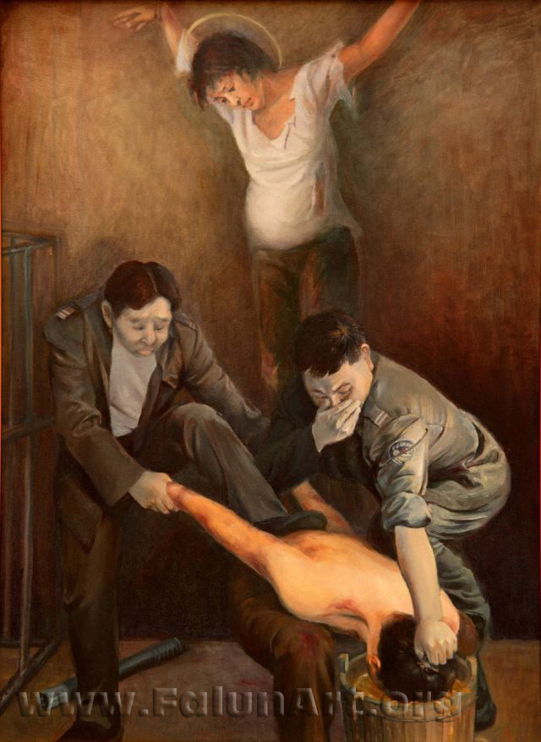
Inhumane
By Xiaoping Chen
Oil on Canvas - 22 in x 30 in - 2004

[Falunart.org] Prison guards are submerging a man's head into a bucket of human feces. One of the guards covers his own nose because of the odor. A pregnant female Falun Gong practitioner is hanging in the background.

[PureInsight.org]

Reporter: In the painting series to expose the persecution, there is a piece “Cruel Tortures,” depicting two evil policemen who were putting a Dafa practitioner’s head into a bucket full of excrement and urine and hanging a pregnant lady on the wall. Could you please talk about the origin of the story depicted by this painting?
Xiao: They are from true stories but I put them into a single painting for presentation. Among their tortures on female Dafa practitioners, hanging up is nothing. I have no way to depict those very dirty and cruel means. Hanging up young pregnant practitioner is something I can still depict, but I found no way to depict more serious ones. Pushing someone into a pond of excrement and urine has existed since a long time ago as a way to insult a person’s human dignity.

Reporter: The hardest part to draw in this painting was…?
Xiao: Thinking out the composition of this painting gave me hard time. This painting consists of three parts. On the top part is the pregnant practitioner hung on the wall, serving as the background. Those torturing evil policemen are in the middle and on the lower part is the practitioner, who is being pushed by them. It is not easy to fit them well into a coherent piece and it may seem broken up if not handled properly. Later, I decided to put the evil persons in the dark, giving prominence to the two practitioners and letting the audience focus their eyes on the practitioners since they represent the light.

Reporter: This painting depicts a story of persecution of practitioners. You hope…?
Xiao: The audience will be touched and will know about the existence of these kinds of things, which might be a shock to them. We should have more people know the truth, have them see the real and cruel side of the persecution paintings.

Reporter: As an artist, what kind of role do you play in this anti-persecution movement?
Xiao: As far as I am concerned, I will do well what I should do. When I have participated in exhibitions or have drawn paintings for visitors in a park, I liked to tell people, who seemed to have the predestined relationship with me, the facts and truth of the persecution. I did it in a natural way, having them realize that Falun Gong practitioners are quite normal and nice.

Reporter: Has landscape painting in any way helped you get in your cultivation?
Xiao: Yes. Traditional Chinese painting of mountains and waters expresses a certain mood, showing the relationship between mountains, water, and human beings. Enjoying a good landscape painting makes you feel as if you are personally on the scene, giving you relaxed, happy, smoothed-out, and comfortable feeling, making you forget your troubles. It is a visual enjoyment to view a good landscape painting.

Reporter: Among the painters participating in this exhibition, many are professional oil painters. You are professional watercolor painter, but participated in the exhibit with oil paintings. That is very special. How do you feel about the difference between Chinese painting and western oil painting?
Xiao: Traditional Chinese painting has its own fine and beautiful means and techniques of artistic expression, such as lines, moods. It has developed in a way different from oil painting. Both of them have their own beauty. Oil painting does a better job in showing the three-dimensional effects and fine features of things. It is closer to real things and people’s actual life. Traditional Chinese painting emphasizes more the creation of moods using freehand brushwork, giving you a feeling of avoiding earthly concerns and being aloof from the vulgar. Buddhism and Taoism have been spread throughout Chinese history and Confucianism has been the mainstream among all schools of thought. Most Chinese people have been influenced by the thoughts of Confucianism, Buddhism, and Taoism and, therefore, feel it easier to accept traditional Chinese painting. Western oil painting is very close to real things, and is very stereoscopic, belonging to a totally different style. I would like to probe into and learn more about the techniques used in oil painting to produce the feeling of thickness and heaviness, to paint realistically, and to display a certain atmosphere.

Reporter: What is the most important thing for one to become a good painter?
Xiao: That is the cultivation of one’s heart. Since my childhood when I started learning painting our teachers, including the teacher who taught us mountains-and-waters painting, told us that one must have a high moral standard if he wants to be a good painter. One must hold a high moral standing if he wants to produce high-grade paintings. Therefore, I think it’s a very good thing for an artist to get into cultivation.

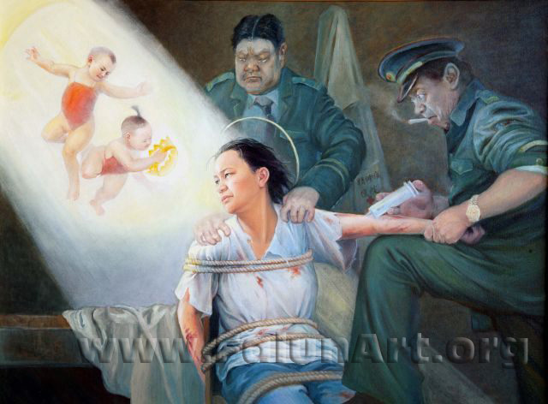
Psychiatric Abuse
By Xiaoping Chen
Oil on Canvas - 40 in x 30 in - 2004

[Falunart.org] To turn public opinion against Falun Gong, China's state-run media disseminates false propaganda that claims people who practice Falun Gong will turn psychotic. The policemen in this picture inject psychotropic drugs into the woman because she refuses to give up her beliefs. The drugs may cause slurred speech, paralysis or even death. "Reeducation classes" often accompany such treatment. The light in the picture represents that even with such means, it is impossible to change a righteous heart.

Guide: This painting is called Psychiatric Abuse. The writing on the lab coat in the background says “Psychiatric Hospital” but these men obviously are not doctors.
In the eyes of the practitioner can be seen a strength and a sadness, but not sadness for herself, there is a strong sense of compassion in that look of longing.
There is a sharp contrast in the refined nature of her complexion compared to the base lower dimensional skin of the evil police. In the eyes of the one injecting her you can see a disbelief shifting to fear, they tried to break her spirit physically and could´t. How can she be so strong? Now they are resorting to chemicals and she remains compassionate and kind, hence the fear. What does that make them?
The one holding her looks like a beast, his hands gripping her like claws. The light from the vision is obscuring the beast behind her, as heavenly beings are rewarding and encouraging her to hold on and stay true to herself. They have her body but they don´t have her, she is in a place of light.

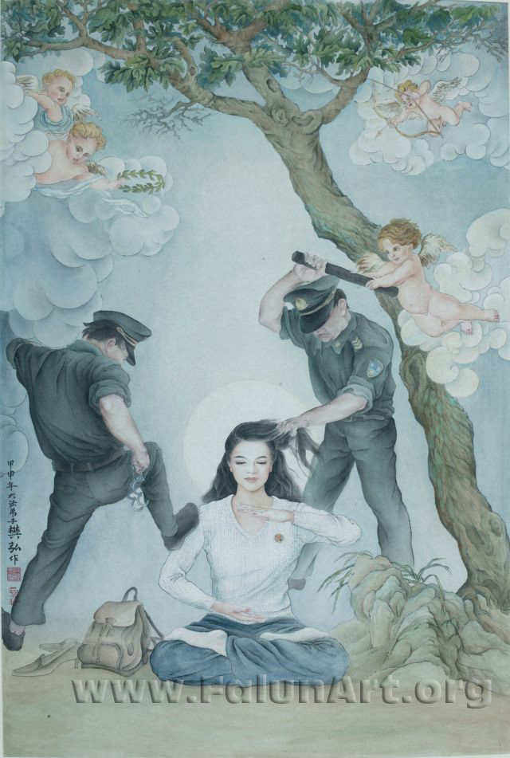
Unmovable
By Amy Fan
Chinese Painting - 34 in x 55 in - 2004

[Falunart.org] This Chinese painting shows a woman in meditation who is unmoved by police who are trying to arrest her. Angels are trying to restrain the policemen. The artist paints from personal experience, having endured the violence of the persecution. She was detained several times before she was finally able to escape from China.

Guide: This painting was originally painted on silk. A perfecting art form with no room for error.
The entire outline is painted first, with just enough moisture it will adhere and won´t spread throughout the silk. In every stage of the painting it has to be fixed in a chemical treatment. The colors are made from natural sources like tea or minerals slowly the transparency becomes colored after dozens of applications, in a most careful manner.
This painting shows a scene of one of the times she was arrested for meditating with a clear and calm mind she remains unmoved, in a state of stillness. The cherubs with the kind and gently expressions represent how she felt the forces around her were restraining the police from harming themselves in the act of harming her.

About Amy Lee
Amy Lee is a Falun Gong practitioner. She was a successful fashion designer in China and enjoys traditional Chinese painting as her favorite pastime. She had a very successful career and a harmonious family with her husband and a daughter. Jiang Zemin destroyed her family and her career when he banned and started to openly persecute Falun Gong practitioners on July 20, 1999. Moreover, Amy Lee was repeatedly arrested and incarcerated in Chinese prisons where she was subjected to many types of torture. She was once taken to the 13th Precinct of the Public Security Bureau in Beijing for interrogation during which a policeman stripped her naked and kept beating her until she passed out. When she refused to renounce her belief in Falun Gong despite the Chinese police’s abuse and torture, the police transferred her to a psychiatric hospital where she was subjected to the torture of force-feeding, the number-one cause of death of Falun Gong practitioners, although she was not on hunger strike. The Chinese Communist government often locks its dissidents in psychiatric hospitals and tortures them by giving them psychiatric drugs. Later the “610 Office” in Guangzhou abducted Amy Lee and threw her to a local forced brainwashing facility where she suffered from mental torment. After she escaped from the forced brainwashing facility, she had no choice but to leave her home to avoid additional torture. With the help of kindhearted people, Amy Lee escaped to the United States in 2001.
Amy Lee is a victim of Jiang Zemin’s persecution of Falun Gong practitioners. She has witnessed the Chinese Communist regime’s brutalities against Falun Gong practitioners, Falun Gong practitioners’ steadfast belief, and how they repeatedly triumphed over threats of death. Inspired by the beauty of Falun Gong and its practitioners’ undying courage and compassion despite the injustices against them, Amy Lee decided to tell the stories of Falun Gong with her heart and her brushes in order to awaken people’s consciences and senses of justice.

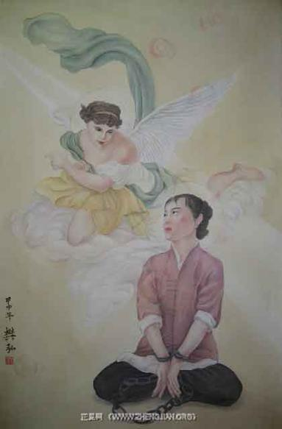
Faith Unchained
By Amy Lee
(53 X 33), 2004

[PureInsight.org] Inspired by her own experience of being incarcerated in the Chinese prison, Amy Lee created this painting to express Falun Gong practitioners’ determination to adhere to their belief in Falun Gong’s cultivation principles, Truthfulness, Compassion and Forbearance, despite being deprived of their freedom and subjected to daily verbal abuse and violence in the forced labor camps and prisons in China. The female Falun Gong practitioner is fearless in the face of torture. She insists on sitting in the Full Lotus position although her wrists and ankles are chained, suggesting she is incarcerated in prison and suffering from some type of torture. Her peaceful countenance reveals that she refuses to abandon her faith or become like the depraved torturers in the prison. An angel visits her there, giving her strength and courage to overcome the demonic tribulations.

Guide: This remarkable painting was done on transparent silk. This is a perfecting Chinese art form. The colors are from natural pigments; for example the tan color is created from tea. The complete outline is first painted then fixed to the silk carefully layer by layer; the mineral paint builds on the transparent silk. This is a self portrait of the artist, sharing a most memorable experience she had. After being beaten and tortured for almost two weeks, she was in severe pain; every inch of her body was in sheer agony. Still chained as she was, she put her legs in full lotus and began the 5th exercise: strengthening divine powers. As it is illustrated in the painting, spinning rainbow colour Faluns appeared all around, healing her. Then, an angel came and gestured her on. She followed the angel and saw a most wonderful scene and the paradise awaiting her. When she came back to her body, all her pain was gone and she was healed. In this rat- infested cesspool of horror, there she sat with this most beautiful expression of wonder and bliss; nothing could get to her anymore. When they tried to brainwash or torture her again, she would remember her vision and this expression illustrated here would fill this dark place with light. She swore to herself that if she ever made it out alive, she would paint this experience.

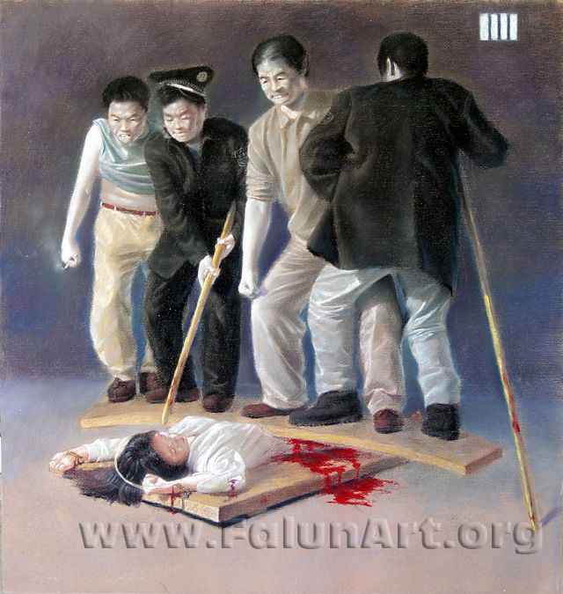
Group Torture
By Zhiping Wang
Pastel on Paper - 22 in x 22 in - 2004

[Falunart.org] The men torturing this young woman are Chinese prison guards and prison inmates, working in concert. The extreme weight on her lower abdomen severely inhibits the practitioners breathing and can result in paralysis.

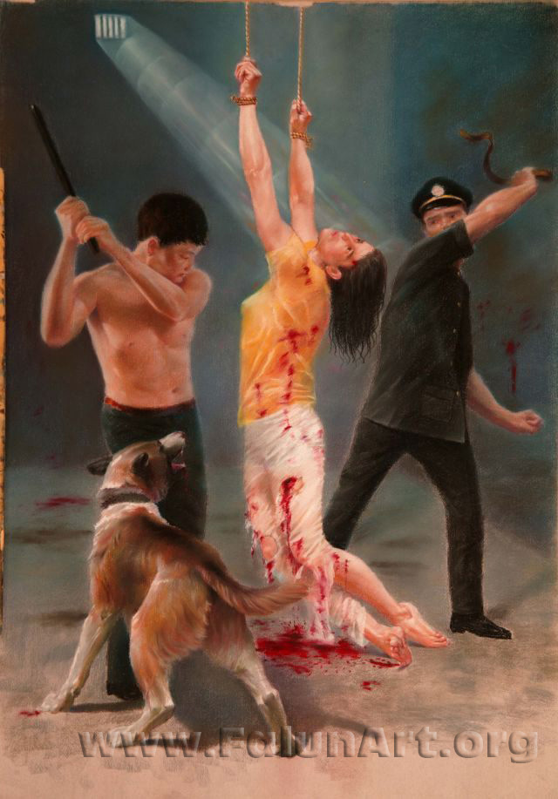
Relentless
By Zhiping Wang
Pastel on Paper - 22 in x 30 in - 2004

[Falunart.org] This is a scene from a Chinese detention center, where prison guards are given directives to "transform" people who practice Falun Gong; that is, force them to renounce their beliefs. When brainwashing classes do not work, practitioners are subjected to relentless beating and torture, sometimes unto death.

Guide: This painting vividly portrays one of the many horrible tortures that the torturers at detention centers, prisons and forced labor camps in China most commonly use on Falun Gong practitioners who refuse to give up their belief in Falun Gong. This is an extremely cruel type of torture. Many Falun Gong practitioners have lost the use of their arms after being hung in the air by the arms for long periods of time. While being hung in the air, Falun Gong practitioners are often subject to beatings by clubs or sticks, as well as beatings by leather whips.

At first glance this drawing could seem like just a disturbing torture scene actually the artist is telling a different story, if you look closer.
It draws you in from the splayed legs of the dog up to its mouth to the bite on her leg, the lines in her pants, the splash of blood, to the drag of her feet, up to the policeman with the snake like belt. There a swirling storm of violent chaos around her. In the policemen eyes there´s there´s a shifting from disbelief with an unwillingness to do it, to fear, of what it makes him.
As she holds tightly onto the ropes, in this hurricane of violence there´s stillness in her gaze, like she´s in the eye of the storm. She has gone within and beyond, with the light showing she has transcended the situation. Even in this dark place the artist has shown the triumph of the human spirit.

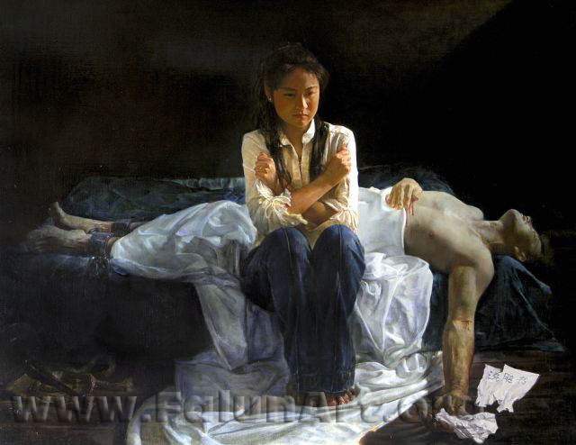
A Tragedy in China
By Yuan Li
Oil on Canvas - 46 in x 36 in - 2004

[Falunart.org] A wife weeps beside her husband, who has been tortured to death at a brainwashing center. He holds in his hand a document that he was forced to sign, a pledge that defames Falun Gong.

Guide: This powerful masterpiece was painted in oils by Yaun Li, a Japanese Practitioner of Falun Gong.
A torn and crumpled remittance paper lays at the hand darkened by the blood gathering at the lowest point. The artist left it to the viewer to decide whether the practitioner signed the paper stating he would give up his beliefs in Truthfulness, Compassion and Forbearance.
I think the artist left some clues as to whether signed it or not, as you follow the arm to the upturned face then across the chest - even in death he looks beautiful, to a golden light coming from beneath his hand. Perhaps showing a golden heart of someone who held true. To the stark coldness of the background. The shackles, snake-like rope and baton indicating the wickedness that had taken place there. In contrast to the warm light on the woman in the center. The wedding ring on her finger indicates she´s the dead practitioners wife. The artist has emphasized an uprightness about her, in the lines in her pants and the lay of her hair and also the light on her arm making her seem like a pillar of light in this dark place. The artist has placed her and the white sheet in the scene to show that the horror and suffering goes beyond the practitioner´s imprisonment and torture, to their friends and family as well. His suffering ended with his death, hers continues. The most telling part of this panting is the expression in her eyes - a sadness yes, but strength as well. The intensity in her gaze showing her determination. The focus in her eyes meeting just in front of her, viewed from any angle. Her crossed arms and firmly closed hands, but not clenched expressing a strong determination not to be broken. Or fall into hate or revenge but to hold true to her convictions. The artist´s use of light in this work is incredible. Through the whole process of creating this work with a technique called glazing, he would have continually have brought the light forward enriching this piece with natural light to create this marvelous master piece.

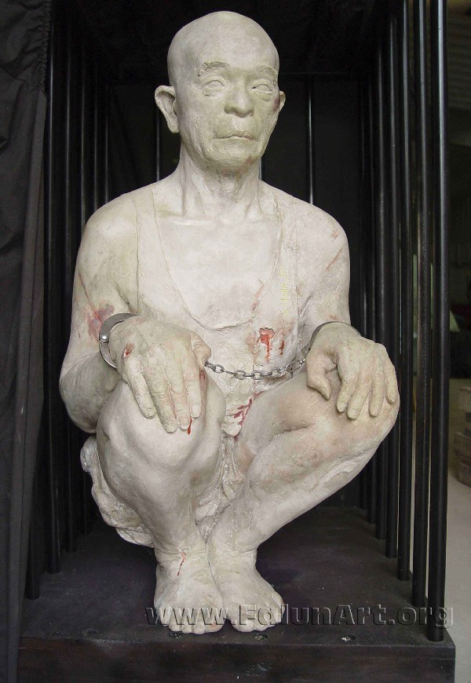
Cage
By Kunlun Zhang
Sculpture - Height: 35 in - 2004

[Falunart.org] While being detained, Falun Gong practitioners are forced to squat on their heels or on tiny stools with ridges on them day and night without being allowed to move or speak.

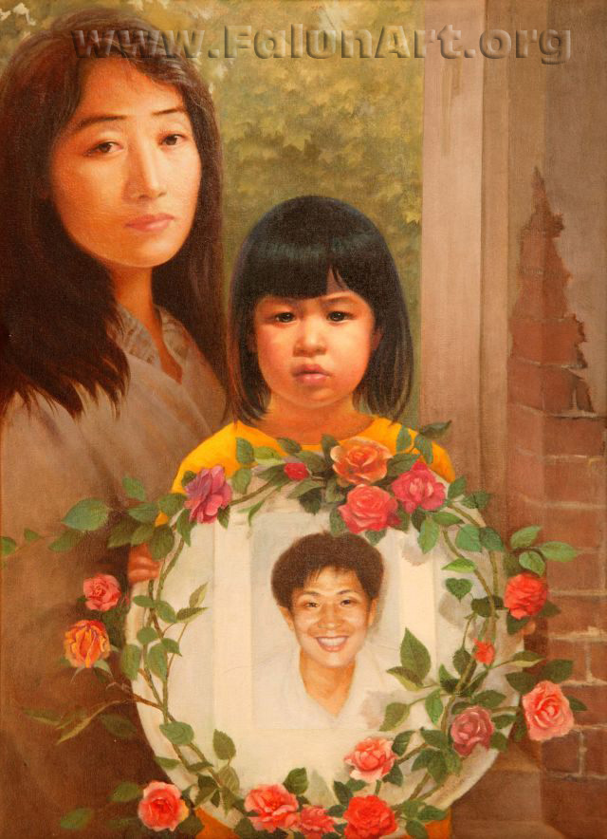
Come Back Daddy
By Weixing Wang
Oil on Canvas - 22 in x 30 in - 2004

[Falunart.org] Come Back Daddy is based on a true story of a mother and daughter. The young girl, Fadu, holds a commemorative picture of her father, Chen Chengyong, who died from torture because he practiced Falun Gong. Fadu and her mother, Zizheng Dai now live in Australia.

Dai: Three years ago, on July 26, 2001, my roommate read the news about my husband’s death on the Internet. She was afraid that I could not bear it. At around seven o’clock on the next morning, before she went to work, she finally decided to tell me. She asked me to come with her and take a look at an article on the Internet. At that time, my daughter Fa Du was still sleeping. I went over and looked at the article. I went into shock and began to tremble uncontrollably as soon as I read the news. It said that the decomposed remains of my husband had been found. The authorities called my husband’s sister to identify the body. When she got there, she was arrested and sent to a forced brainwashing class. I turned to look at my daughter, who looks a lot like her father. I could see my husband in her. My heart was broken. I locked myself in the room and did not want to see anyone. My hair turned white in just one night. The pain was beyond description. I am really grateful that Falun Gong teaches me to consider others first. After I immigrated to Australia, I had gone back to China and lived there for 8 years. Many of my good friends there are in jail because they practice Falun Gong, and their children suffer from the pain of losing their parents. I decided that, as a mother, I must speak up for those children. If I didn’t do it, who would do it? So in 2002, I took my daughter to attend the International Human Rights Conference in Geneva, calling for all mothers around the world to help stop the torture of Falun Gong practitioners. From Geneva, I began to travel around the world urging people everywhere to help end the persecution against Falun Gong.

Guide: The artist set the scene in the doorway of the home where the girl´s father should be. The exposed brick in the crack on the wall symbolize the broken home and lines up with the mother´s eye´s forming a V, to draw you into the panting. To Fadu´s face then to Jane Dai´s and back to the father the artist said it was an extremely difficult painting to do. To balance of the three faces, so one didn’t´t overpower the other. She worked on them over and over. So as you stand at different angles a new expression emerges. Another extremely complicated aspect to this painting is the use of warm colors in cold places and cold color´s in warm areas on the faces. Her years of studying the master pieces in Paris show in the volumes of expressions. Jane Dai has tirelessly told her story to all who will listen, of how at the beginning of the persecution her husband went to the appeals office in China to tell them there must be some mistake, Falun Gong practitioners are good people! They eventually tortured him to death for this. Fadu name means, saved by Fa. Fa means law, or principles, the principles of Truthfulness, Compassion, and Forbearance. The expression in there eyes speak right to the heart.

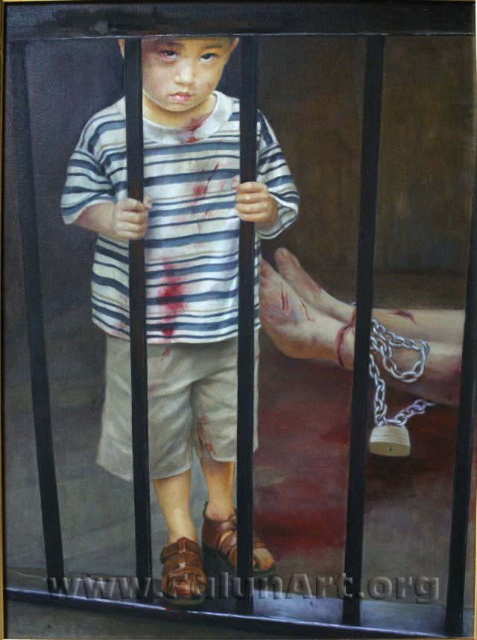
Why?
By Weixing Wang
Oil on Canvas - 52 in x 68.5 in - 2004

[Falunart.org] This painting is based on a true story. A mother and son were arrested in China simply because they practice Falun Gong. Being beaten, the boy held back his tears asking: Why? Why did the policemen beat my mom and me?

Guide: This was painted upon the request by a practitioner in NY. This happened to her and her son. They where lucky enough to escape from China and now live in Flushing NY. She wants the world to know there are many children in these dark places. Some times they leave the children on the streets as orphans, sometimes they abduct them as well.
This powerful work invokes deep feelings. The composition with the bars and horizontal lines on his shirt reminds one of a concentration camp. You can see in his face, after being in there and seeing all those horrors, he is left with only the emotional question - Why? Why did they do this?

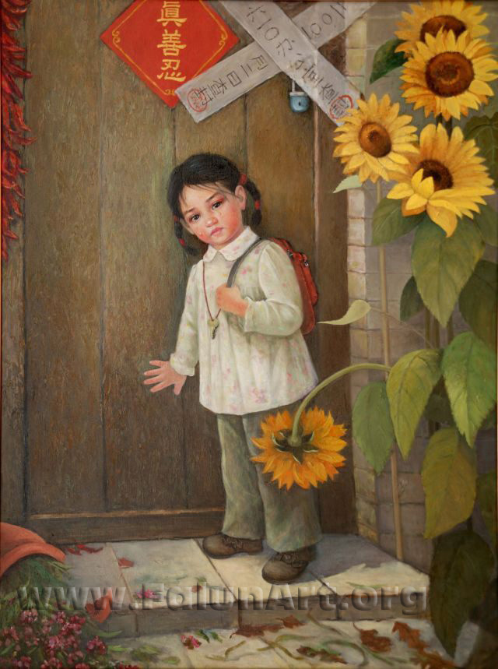
Homeless
By Daci Shen
Oil on Canvas - 36 in x 48 in - 2003

[Falunart.org] This painting depicts a scene in which a little girl comes home from school only to find her parents gone. The two pieces of white paper on the door are official notices stating that the house has been condemned by the "610 Office," a Gestapo-like organization set up specifically to target Falun Gong. The red paper on the door reads "Truthfulness, Compassion, Forbearance."

Guide: This next painting is a true story and sadly an all too common one as well.
In this painting, the artist has used the bright flowers to denote a happy home of practitioners indicated by the red sign saying “Truthfulness, Compassion, and Forbearance”. She has come home from school to find the door padlocked and warning labeled. With the words 610 office confiscated. The 610 office in a name given to a Gestapo like agency in China that´s above the law and carries out the most heinous crimes. The downward turned flower adds to the composition and to the sadness of the scene. Also the artist gives the impression of the force that went through earlier by the broken vase and 610 written in the plant and leaf debris on the ground.
The little girl stands by the door in a mature way with tears rolling down her face upset yet her eyes revels a strength giving hope. The artist is showing she is a practitioner as well and will not be broken.

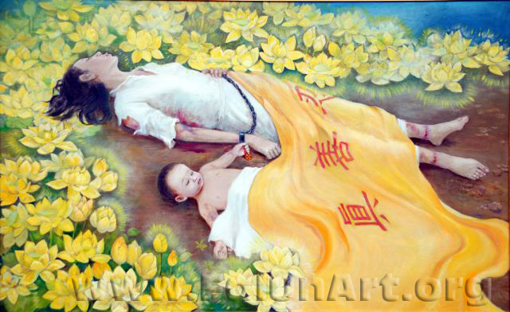
Golden Lotus
By Daci Chen
Oil on Canvas - 69 in x 43 in - 2004

[Falunart.org] The inspiration for this painting came from a true story that has raised an international outcry. A young mother named Lixuan Wang and her 7-month-old son were both tortured to death after they were arrested for practicing Falun Gong. Autopsy reports revealed that the baby had been hung upside down and his skull had been crushed.

Guide: (Note this panting should be displayed above head high if possible above the painting Memorial.)
This painting the Golden lotus is a Memorial to the youngest person known to be killed in the persecution, and his mother. The cloth draped across them reads Truthfulness Compassion Forbearance. The golden lotuses symbolize purity as they spread, like their is story being told.

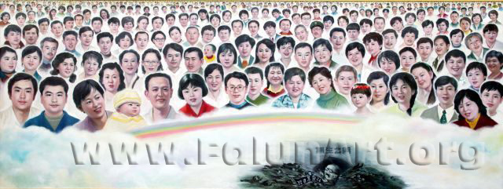
Memorial
By Chongqi Yao
Oil on Canvas - 110 in x 42 in - 2004

[Falunart.org] This painting is in remembrance of some of the more than 1200 Falun Gong practitioners who are known to have died under the brutal repression. The artist said, I painted the faces of 280 practitioners to let more people see these good people and to help stop this persecution. Look at how happy they were! They were all very good people in the society. Whenever I think of them, I cannot hold back my tearsyou know, some of them were only seventeen or eighteen years old when they were tortured to death.

Guide: (Suggest to learn about some of the people shown here who they are, what they did for a living, what happened. Can also point out the ones who are in the other painting like mother and baby, Jane Dai´s husband, the lady who was forced to walk in the snow. Background on there jobs etc, will help bring it home to people.)

This painting is called the Memorial. Below the heavens you see the ex president of the communist party. He is being pulled into the gates of no life along with the police he ordered to take part in the persecution. The artist is an elderly practitioner lovingly painted all these kind practitioners. From photos she collected from Minghui web site (Clear wisdom in English). These people shown here came from all walks of life. Teachers, doctors, and carpenters - you name it. They where all good people - the best people. They lived their life with kindness.

Calling for Justice

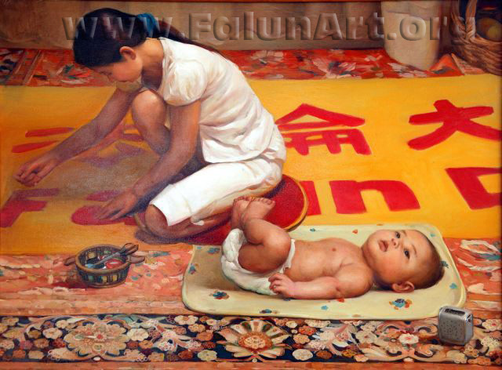
Banner
By Xiqiang Dong
Oil on Canvas - 48 in x 36 in - 2004

[Faluart.org] The young woman is sewing a banner with the words "Falun Dafa is Good" in both Chinese and English. These are positive words, but they are also considered words of protest because countless practitioners of Falun Gong have spoken or written them in defiance of the efforts of Chinese authorities to tell them otherwise. The lovely baby in the foreground can be seen as a sign of hope, showing that the peaceful and life-giving nature of Falun Gong will prevail.

Guide: This beautiful painting is very realistic and pleasing to the eye. It portrays a day in the life of a practitioner since the persecution started. The artist is very accomplished being able to balance this bright yellow banner with the detailed carpet. The banner says Falun Dafa is good. This is very significant in that Falun mean principle Wheel, Dafa translates to the great way (to heaven). Under the tyrannical rule of the communists, atheism is imposed on the people and they are taught the opposite. The little gray box is an amplifier Falun Gong practitioners listen to the Buddha Fa and exercise music on. By the look in the babies’ eyes he appears to be listening.

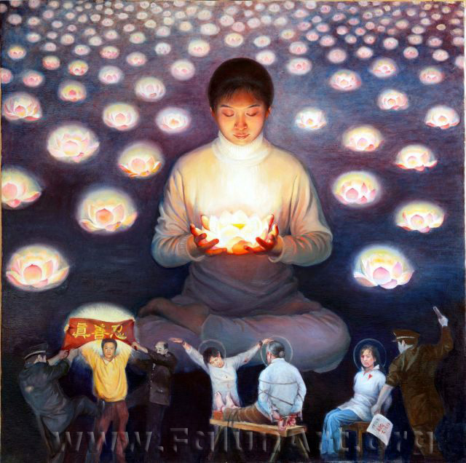
Lotus Candle
By Xiaoping Chen
Oil on Canvas - 40 in x 39.5 in - 2004

[Falunart.org] Numerous candlelight vigils have been held around the world to remember Falun Gong practitioners who have died from torture. The lotus flower is a symbol of cultivation, and purity in Chinese culture because it rises from the dirt at the bottom of a pond. Through the murky depths breaking through the surface into a new reality. Opening only in the light unmarred by the filth from where it came. With a beauty that is better viewed from afar a sent that is nice but not alluring and a stem that can bend easily but won´t break.

Guide: The Lotus Candle. In the foreground you see a young man upholding the principles Trustfulness, Compassion, Forbearance. The artist was inspired by a photograph of this courageous man and wanted to memorialize him in her panting. The police are applying great force but look very week. He is unmoved standing firm with his beliefs. The women being tortured are upholding those principles as well by not giving in. The other police man holds a paper the practitioner signed with the word Falun Dafa is Good. It is the opposite of what he was forcing her to sign. The circles around there heads symbolize holding true to ones beliefs in all circumstances.

Above you see a Falun Gong practitioner holding a lotus candle in front of her heart. She is holding a human life in her hands. The lotus candles spreading out like an ocean represent practitioners around the world clarifying the truth about the persecution. The artist also said the candles are her wish that people of the world hearts will light as they become aware of the persecution and it will stop.

[PureInsight.org]

Reporter: You have a painting, “The Shining Lotus Hearts”, which has attracted a large audience during the exhibition. The sharp and nice contrast between light and dark in this painting easily catches people’s eyes. Could you please talk a little about the creation of this painting?
Xiao: The inspiration for this work came when I came here last year to participate in the “7-20 Candlelight Vigil” before the Washington Monument. I sat in the first row with a candle in my hands and a feeling of holiness and solemnity in my heart. Sitting there, the glorious atmosphere frequently gave me an impulse to cry. I saw so many practitioners, each having a candle in his hands. A candle is simply a bright lantern in the dark, so warm and so touching.
In this painting, every lotus is a heart. She holds the lotus just like holding a heart. Every lotus lantern represents a golden heart of Dafa practitioner, which has been dedicated to the common people to light up this world in the dark. Imagine if millions and millions people all had such a heart! People use candles to express their tribute and cherishing the memories of people who have passed on. Therefore, I have combined them together. Cruel tortures have been presented in the lower part, letting people know that she is cherishing her memory of those practitioners who were tortured to death. That practitioner is unfolding a banner with words “truthfulness, compassion and tolerance” on it, which, like a bright lantern, sends out light to light up the dark. Indeed, different forms were used to express the same idea.

Reporter: Could you please talk about the composition of this painting in more detail?
Xiao: This kind of composition is relatively a traditional one, which has the figure in the middle to form a composition in triangle style. Historically, this kind of composition had been used in many oil paintings, especially in those paintings with religious subjects. Putting a figure in the middle, is a way to express the feeling that the figure is solemn and holy, which can confer such an atmosphere. I feel this kind of composition is the best one to express my feelings. Someone told me that the lantern seems alive and is moving. The lantern is in a warm tone. Because of the effect of lantern light, a face will be different from what people commonly see when the lantern shines on it. That girl’s pure and dignified face, together with the cruel persecution, forms a sharp contrast, bringing people a shock. A kind of inner strength comes out from her tranquillity, very touching. I have used one figure to represent all the practitioners.

Reporter: When I saw this painting from a distance I was attracted. The lantern in her hands is very warm. I first saw this lantern and then saw the girl’s face lit up by this lantern. Finally, I saw the surrounding and the lower part. That lantern is very attractive and it is hard to draw light. Do you have much experience drawing light, or this is the first time?
Xiao: All the light I drew before was sunlight. All the watercolor paintings I drew before were bright and splendid landscapes under the sunlight, with sunlight bouncing on a human being’s body. It is my first time to draw candlelight. Then, I had a strong feeling: I surely can draw it well! Indeed, I feel quite satisfied with what I drew, and the effect is quite remarkable. At that time, I lit up a candle and held it with my hands, having my picture taken. There was another reference for the lotus. The background has been simplified. The artistic treatment is to draw many lanterns, representing millions and millions Dafa practitioners’ hearts.

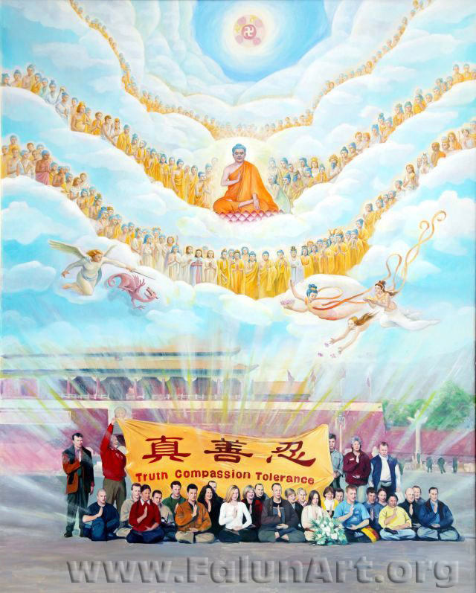
Coming for You
By Yixiu Zhou, Xiaoping Chen
Oil on Canvas - 51 in x 64 in - 2004

[Falunart.org] This painting is inspired by a photograph taken of thirty-three practitioners of Falun Gong from all over the world who coordinated a peaceful appeal to the Chinese Government on Tiananmen Square. Moments after the photograph was taken, they were thrown into police vans, many were beaten and then all were expelled from China.

Guide: This painting depicts a historical moment; never before in the history of the world has anyone done anything like this: going to a foreign country to try to save those people in such a peaceful way. This photograph is hanged in Buddhist temples; it so moved the Asian people that Caucasians would come and risk their lives for them.
The western practitioners got together once before going there and drew a picture to decide where each would sit. They all came from different countries on various modes of transportation. Miraculously, the all arrived at the same time, in the same place, positioning them selves perfectly for the photograph to be taken. Some described how on the way there, they struggled not to be scared. However, when it came to the time to go to Tiananmen, the fear was gone. They felt they were part of something much bigger than themselves; they sensed that even the air itself was watching this moment. The artist has represented what they sensed with the heavens full of a multitude of different Gods, present for this moment, with many of the heavenly beings pressing their hands together in Heshi
(a sign of respect and greetings.) The heavenly beauties drop flowers in an offer of blessings. (The angel casts off a red dragon symbolizing the beginning of the end for communism)[note the line in brackets perhaps best not to say to main land Chinese otherwise ok]. The practitioners were arrested, beaten, held for a time, and then deported. The light shining from what they did that day reaches all the way to the heavens.

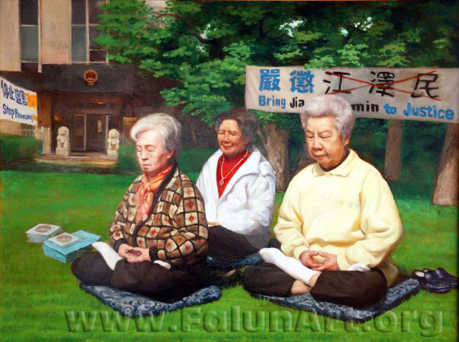
Calling for Justice
By Xiqiang Dong
Oil on Canvas - 48 in x 36 in - 2004

[Falunart.org] This painting depicts a scene that can be seen in front of Chinese embassies and consulates all around the world. The women in this picture practice their meditation in front of the Chinese Embassy in Washington, D.C., calling for Jiang Zemin to be brought to justice his attempted eradication of Falun Gong practitioners. These women go to appeal there every day, rain or shine.

[Pureinsight.org]This painting depicts a daily scene in front of Chinese embassies and consulates around the world. The elderly women in this painting practise Falun Gong’s meditation in serenity in front of the Chinese Embassy in Washington, D.C. and call for the world’s help to bring Jiang Zemin to justice for his genocide against Falun Gong practitioners. The small park in front of the Chinese Embassy in the U.S. is known as “Tiananmen Park” among the Chinese Communist government’s dissidents.

The elderly female practitioners pictured in the painting have been appealing in “Tiananmen Park” every day, rain or shine, since Jiang Zemin started to openly persecute Falun Gong practitioners in China on July 20th, 1999. One of them once had problems with her normal transportation and decided to walk four hours to the Chinese Embassy in Washington, D.C. so that she would not miss the opportunity to send righteous thoughts and support her fellow practitioners in China. Each day the practitioners practise Falun Gong’s meditation there to exhibit the peacefulness, rationality and kindness of Falun Gong. Their daily ritual manifests their determined yet peaceful spirit and also embodies the message that Falun Gong is good. From them, we can see their conscience and humanity as well as their unwavering courage to uphold human dignity.

An elderly Falun Gong practitioner who had been illegally detained five times in China said that she goes to the Chinese Embassy to have people understand that Falun Gong is good, and to call for people’s help to end Jiang Zemin’s persecution against Falun Gong.
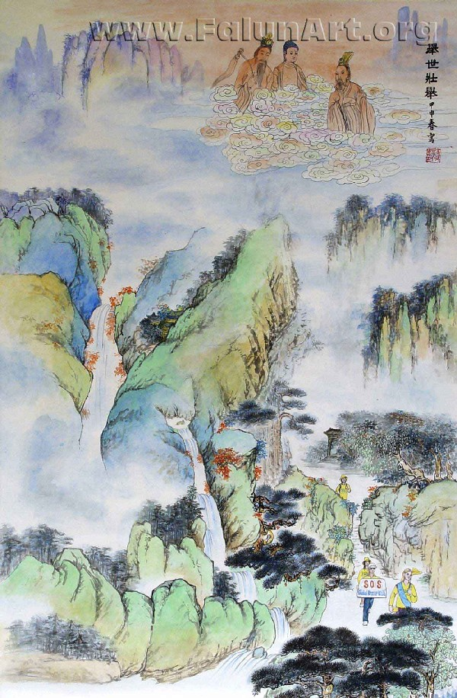
SOS
By Yanying Wang
Chinese Painting - 25 in x 37 in - 2003

[Falunart.org] In the Chinese landscape painting, walking through the mountains are men and women taking part in a human rights "SOS" campaign that has been carried out around the world to raise awareness about the genocide of Falun Gong in China.

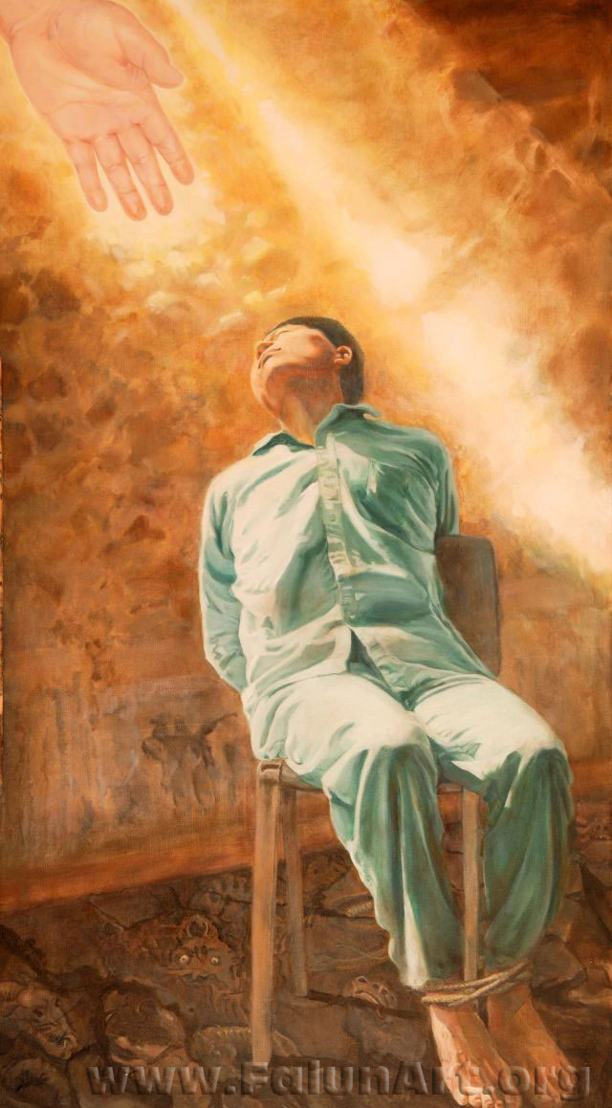
Uncompromising Courage
By Kathy Gillis
Oil on Canvas - 32 in x 57.5 in - 2004

[PureInsight.org] This painting was based on a true story of Mr. Liu Chengjun. Mr. Liu Chengjun was a Falun Gong practitioner from Changchun City, Jilin Province, China. In March 2002, he was sentenced to 19 years in prison for his involvement in broadcasting video programs over Changchun City cable television network that revealed the truth about Falun Gong and exposed the Chinese Communist government’s brutality in the persecution of Falun Gong practitioners. He died in prison after 21 months of torture. He was one of the few Falun Gong practitioners who pioneered the broadcasting of truth-clarification video programs over the Chinese TV networks.
In this painting, Liu Chengjun is tied to a chair in a torture chamber where the floor is covered with demonic and monster-like images that represent the horrors he endured while in illegal detention. He is basking in warm, golden light coming from the top left corner that represents a resilient faith. A golden hand extends in towards, representing the salvation of the lord of the universe. Liu Chengjun looks up in the direction of the light and the hand, so we cannot see his facial expression. Traces of blood and his injuries are not shown in the painting, but we can derive from his posture that he must be enduring a lot of pain. That he looks up in the direction of the light, instead of hanging his head in despair, implies his uncompromising courage and spirit.

Guide: In this painting Uncompromising Courage, the dignity of Liu Chengjunin is expressed in a unique way. He is kept clean and unmarred, bathed in light with his chin upturned. This courageous man, tapped into the satellite feed and broadcasted evidence showing the lengths the tyrannical communist party would go, in implementing this unlawful persecution. The film broadcasted, revealed that like with other genocides around the world, propaganda was used to demonize a group and instill terror in all who watched. Enough so that people would turn their own family and friends in to be torched possibly to death. The film, a slowed down version, of the staged self emulation tape, exposing to the Chinese people that the mother, daughter and others they saw burning to death on TV, were staged to horrify and turn public opinion agents a group of people that everyone new as good. They showed it over and over again to terrify the population. To make the perpetrators look like heroes. After 21 months in prison, Liu was tortured to death. Demonic and monster-like images under the floor represent the horrors he endured while in detention. The closer they are to Liu the deeper and more suppressed they are. The artist kept him clean, free from wounds blood and filth, to show his dignity. Triangle after triangle can be seen throughout the painting, expressing the strength of character of a man who gave his life to let people know the truth and not turn their friends and family in to be torched and killed. He is bathed in warm, golden light that represents a resilient faith. (Triangles can be pointed out to the viewers in his shirt and clothes his chin, the chair, the wall and light. The whole picture is laid out in triangles)

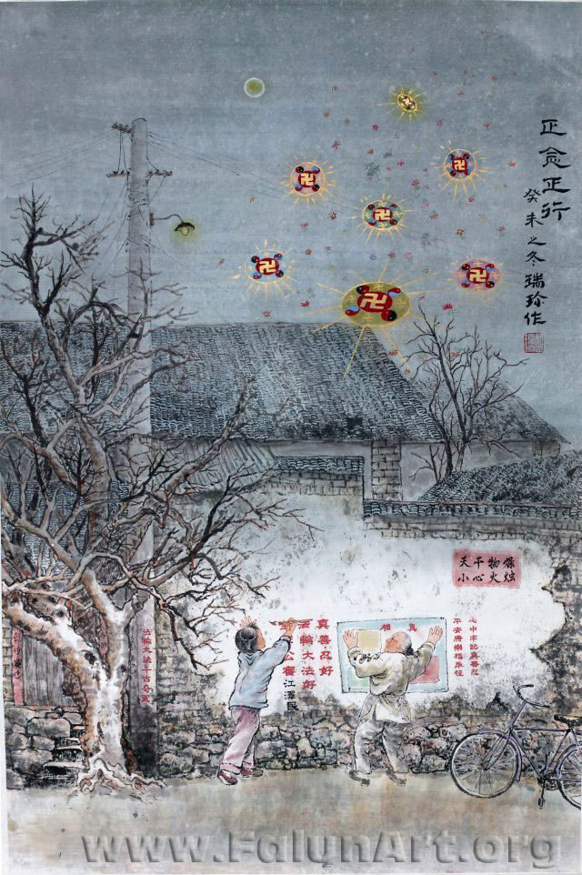
Righteous Actions
By Ruizhen Gu
Chinese Painting - 18 in x 28 in - 2003

[Falunart.org] This Chinese painting depicts a scene in a moonlit night in a small village, where a grandmother and her grandchild post messages that tell the truth about the persecution against Falun Gong to their neighbors. The disc-like objects in the sky are Falun, the symbol of Falun Gong.

Guide: The Artist uses traditional Chinese painting techniques to present a scene in a moonlit night in a small village, where a grandmother and her grandchild post messages that tell the truth about the persecution against Falun Gong to their neighbors. The disc-like objects in the sky are Falun, the symbol of Falun Gong. The swastika in the center of the wheel was always a symbol for good, in the ancient world. Then in WW2 Hitler turned it backwards, attempting to turn it into something bad. Before the war in America it was called the four L:s: Luck, Life, Love, and Light. To practitioners it represents a miniature of the universe.
Notice how the lamp overhead and the full moon have little affect of lighting this darkened scene in China. Perhaps darkened by the lies told by communist controlled media. The Grandmother and granddaughter post banners revealing the truth. The light seems to come from the posters themselves illuminating the way.

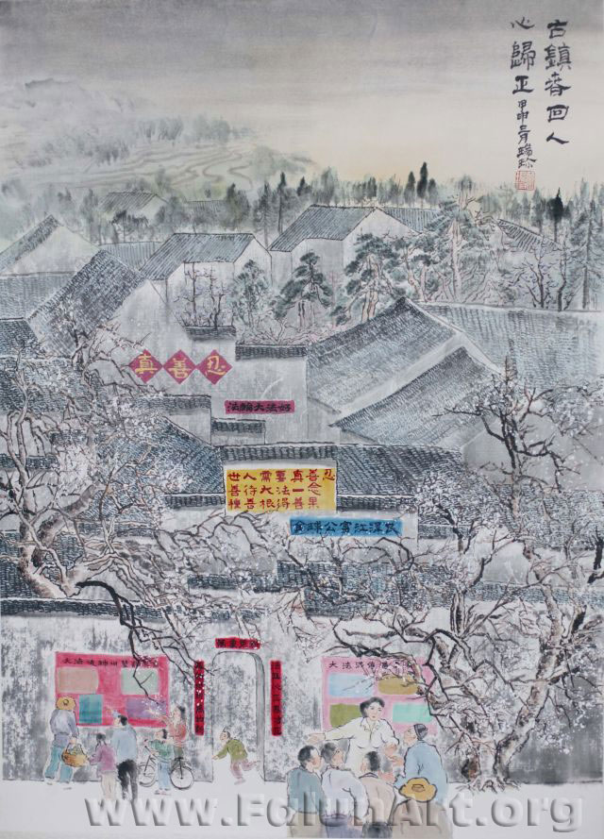
A Spring Morning in a Town
By Ruizhen Gu
Chinese Painting - 20 in x 28 in - 2003

[Falunart.org] The traditional Chinese painting depicts a spring morning in a town when people wake up to find walls posted with signs about Falun Gong. The people read them intently, seeing through the Chinese government's propaganda

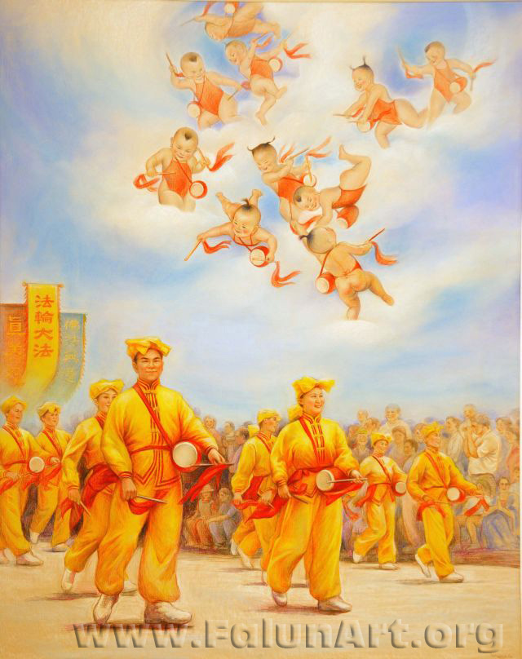
Waist Drum
By Xiaoping Chen
Color Pencil on Pape - 32.5 in x 41 in - 2003

[Falunart.org] In many major cities around the world, people who practice Falun Gong participate in parades to celebrate traditional Chinese culture. The artist has drawn celestial beings playing amidst the clouds, echoing the unified beat from below.

Guide: This cheerful piece, reflects warmth and excitement that the waste drum troop brings to community events. Peoples faces light up upon the drummer's approach.The Yin Hei or Cherubs, who only appear in positive energy fields, exuberantly play along in the sky. A practitioner who could see with her third eye described the to the artist. Some cultivators or people who do self- refinement practice and build virtue, can see with their third eye other dimensions. Usually, the ones who have their eye open are at either end of the spectrum, children with pure hearts or elderly women with few attachments. For all those who couldn't see this joyous display in the sky they certainly felt the exuberant energy as apparent in all the light and happy faces.

Justice Prevails

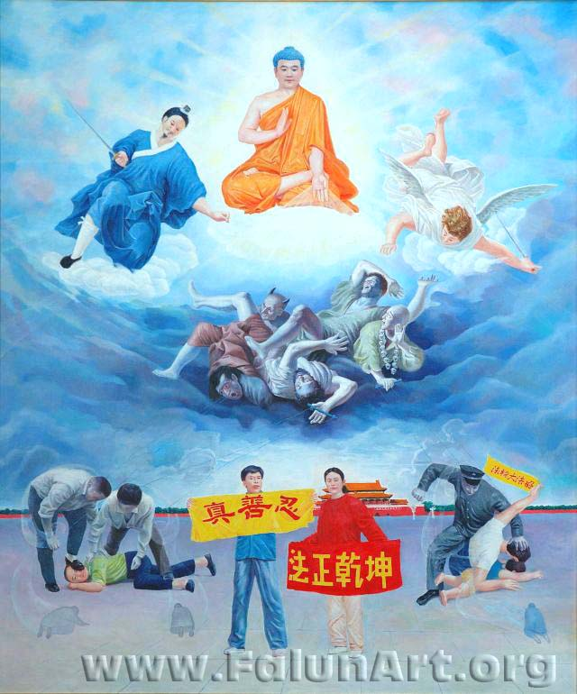
A Battle Between Good and Evil
By Zhiping Wang
Oil on Canvas - 66 in x 79 in - 2003

[Falunart.org] The man and woman in the forefront hold signs that read "Truth, Compassion, Forebearance," and "The Law rectifies the universe." The spirits of the plainclothes policemen bow before their victims, suggesting that the police have been deluded by higher authorities into carrying out orders against their own conscience.

Guide: The practitioners holding banners and being beaten on Tiananmen Square were inspired from the actual photographs of the yellow banner saying Truthfulness, Compassion, Forbearance. On the red banner the characters read: The Law regulates the universe, (in other words the principles T.C.F. harmonize the universe.)
The figures bowing in the foreground represent the persecutors knowing sides or conscience. The hands of the men who are beating the practitioners are white to show they are not in control of themselves. Attached to them are puppet´s strings held by wicked beings that are themselves held in a very suppressed and helpless manner by a demon. The demon has them because in another life, these men did some very evil things. For example, the one with the strings coming from his mouth probably said something to cause terrible harm and the one with the necklace of sculls perhaps a voodoo sorcerer. Now they are being controlled by a demon in this life through their karma to do even more evil things, so they will be destroyed. Above, there is a Buddha shining his merciful light. The Tao (a Chinese God) and an angel hold swards, they are poised and ready, waiting for those men to listen to their conscience and stop. Then they will cut the strings and the merciful Buddha can save them as well.

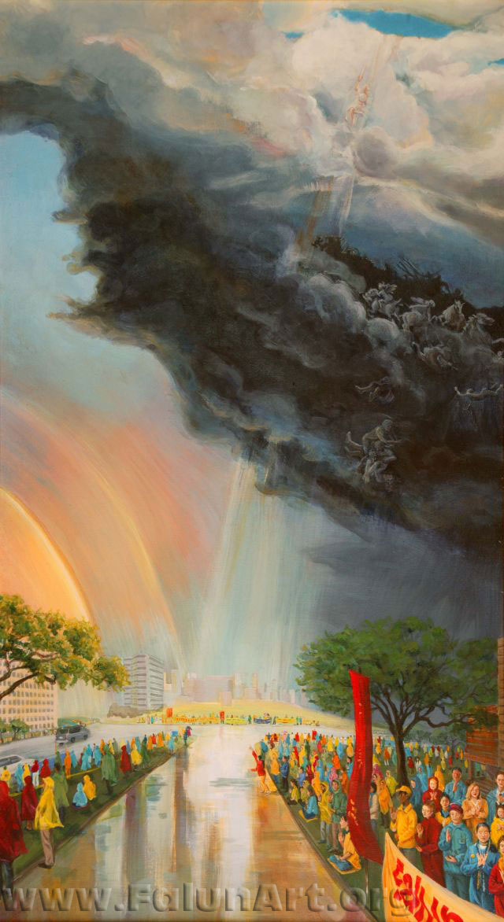
The Heavens Speak
By Kathy Gillis
Oil on Canvas - 32 in x 57.5 in - 2004

[Falunart.org] This painting illustrates the artist's personal experience. When China's former leader, Jiang Zemin, visited Houston, Texas in October 2002, thousands of people who practice Falun Gong went there to appeal for an end to the persecution. During their appeal, practitioners withstood several days of severe, cold weather and heavy rains. The practitioners refused to be affected by the weather and stood their ground. Finally the storm cleared and a huge rainbow appeared in the sky. This painting captures that moment.

Guide: When China's former leader, Jiang Zemin, responsible for ordering the deaths and persecution, of so many millions of people including Tibetans, Christens and Falun Gong practitioners, visited Houston Texas in October 2002, thousands of people who practice Falun Gong went there to appeal for an end to the persecution. Letting the people know the crimes of the one they where meeting with. During their appeal, practitioners withstood several days of unseasonably cold weather and heavy rains that fell unceasingly for over sixteen hours. Practitioners endured the fierce storm standing in ankle deep water. The people of Texas, upon seeing the practitioners there from morning to night rolled down there windows in the down pore giving thumbs up and encouragement as the practitioners refused to be affected by the weather and stood their ground. Then suddenly as expressed in the panting by the girl stepping into the street and pointing up, at six o´clock in the evening - a time when all the practitioners around the world send Righteous thoughts together at the same time. (SFRT is sending positive energy to eliminate the negative things that damage goodness). The storm broke in two, blue sky instantly opened up above the practitioners, with a huge double rainbow stretching from horizon to horizon overhead. The light from the sky above, revealed what appeared to be a battle taking place on the thousand foot high black cloud. As the rumbling black mass undulated and flashed with lightning you could see the figures that the artist painted in the cloud. The artist said during the making of this peace she awoke from a dream with the image of an angel emblazoned in her mind, shooting up and cutting the sky in two, so she added it in. A couple of strange coincidences associated with this event are wherever this evil man (who´s name translates to swamp creature) went on his world tour there were terrible storms hurricanes and floods. Evan a plague of locust biblical in the manifestations. Also the Highway this took place at is called the six ten highway (and smelt like a swamp.) The six ten is the notorious name of the Gestapo like agency that he created to implement the persecution. In the painting, the struggle of kind, innocent Falun Gong practitioners who follow the principle of Truthfulness-Compassion-Forbearance, against the persecution of the dictator, corresponds to the battle between the good and the evil in the heaven. The painting places the heavenly battle in the background and draws the attention of the audience to the righteous Falun Gong practitioners on earth.
(Whose name translates to swamp creature and smelt like a swamp optional but practitioners should know at least)
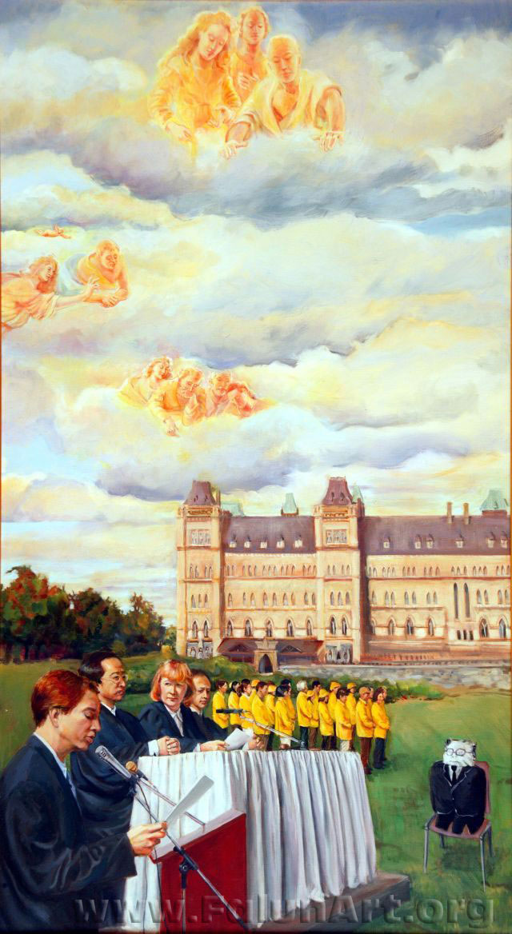
Peoples Tribunal
By Kathy Gillis
Oil on Canvas - 32 in x 57.5 in - 2004

[Falunart.org] This painting depicts a public mock tribunal held in Ottawa, Canada in which Chinas former leader, Jiang Zemin, was tried and convicted for genocide of Falun Gong and crimes against humanity. More than a dozen actual lawsuits have been filed around the world by victims of Jiang's genocide of Falun Gong.

[Pureinsight.org] In front of the parliament buildings in Ottawa this mock trial took place. The puppet represents the accused. In the background wearing the yellow shirts are practitioners doing the exercises, helping to build a positive energy field In the foreground the charges are read, listing the crimes for all to hear. Beings in the heavens above listen in; expressing this mock trial has a greater effect than meets the eye. As in reality, charges have been laid around the world, charging the man responsible, with crimes against humanity and genocide. The play becoming reality. In the clouds the higher the beings positions appeared, the more refined the beings seem and the more receptive to this event on earth.

Guide: This painting depicts a mock trial held in Ottawa, Canada, in which a stuffed puppet representing Jiang Zemin was tried and convicted for genocide of Falun Gong and crimes against humanity. The impetus behind the mock trial were more than a dozen actual lawsuits that have been filed around world by victims of Jiang’s genocide of Falun Gong. A group of Falun Gong practitioners in yellow jackets stand in the background, facing the stuffed puppet representing the defendant Jiang Zemin. Divine beings in the sky watch the mock trial in compassion.
The purpose of featuring several westerner Falun Gong practitioners in the painting is to make the western audience realize the persecution against Falun Gong is right next to them and the trial against Jiang Zemin is something that they should get involved with. Many westerners are indifferent to Jiang Zemin’s persecution against Falun Gong practitioners because they feel it has nothing to do with them and it is just something that is happening on the other side of the world. But the fact is that many pieces of evidence have shown that Jiang Zemin has extended his persecution overseas and even to foreign citizens.

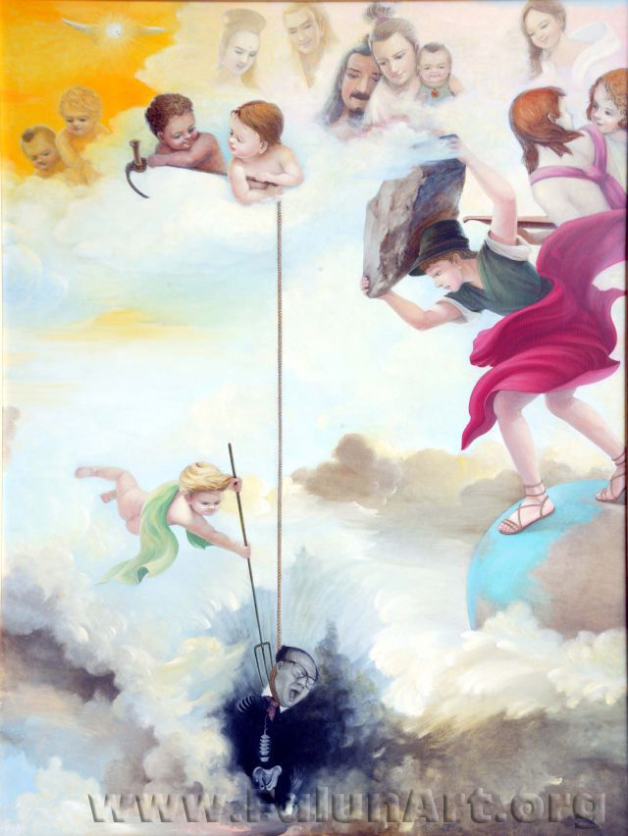
Justice
By Weixing Wang
Oil on Canvas - 52 in x 68.5 in - 2003

[Falunart.org] Heavenly beings look on as the representative of evil is extinguished. The work reflects an understanding that evil actions will result in retribution in higher realms.

Guide: The artist painted this with the understanding that it would be more compassionate for this evil figure, to no longer be in the world as he is responsible for many heinous crimes against humanity and ordering so many people to take part in this terrible persecution. He is being pushed into the gate of no life; his bones can be seen disintegrating away as a European Heavenly being prepares to seal the gate with a rock. They all have very benevolent kind faces in the heavens. A family of three practitioners killed in the persecution look on as the little boy with the pitch fork pushes him in with a bit of a knotty expression on his face. However there is no malice in what they do. It is what must be done for Justice.

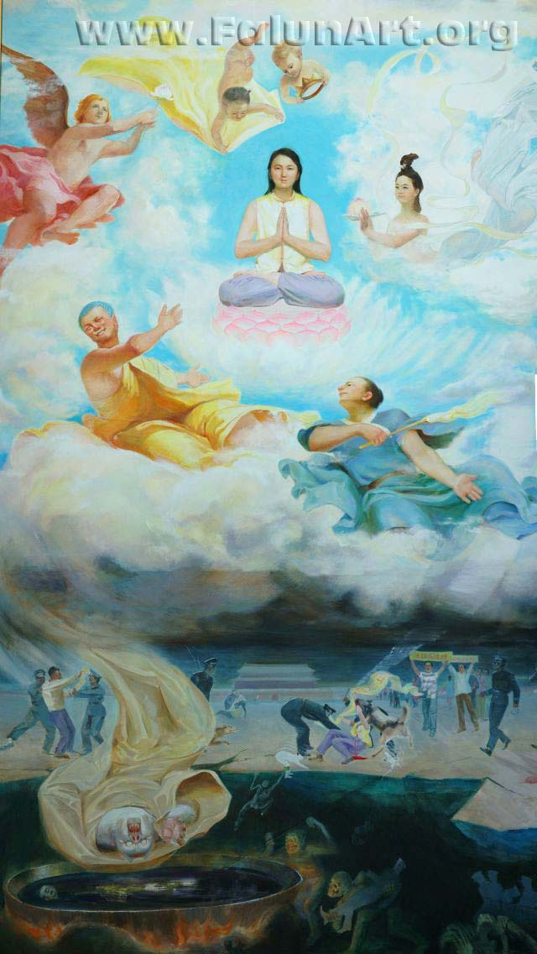
Positioning
by Kunlun Zhang
Oil on Canvas - 67 in x 117 in - 2003

[Falunart.org] This painting captures multiple images of peaceful appeals to the Chinese government on Tiananmen Square in Beijing. Falun Gong practitioners carry signs that read "Falun Dafa is Good" while policemen and plain-clothed guards violently arrest them. Heavenly beings from Eastern and Western traditions are represented looking on.

[PureInsight.org] I would like to tell people a truth through this painting. In the universe there is a principle that nobody can escape: “Good deeds will be rewarded with good, while evildoings will meet with karmic retribution.” Falun Gong teaches people to be better people, but the evil forces brutally persecute them. Everyone’s attitude towards the persecution against Falun Gong determines his position in the universe.
For the depraved police, as they beat Falun Gong practitioners at Tiananmen Square, in fact their primordial spirits are knocked into Hell, and their fates are quite dreadful. Even for this dog in the painting, when it bites Falun Gong practitioners, its primordial spirit has been caught and carried away by the demons to Hell. The Chinese police persecute this female Falun Gong practitioner in the painting because she is telling people the truth about Falun Gong and doing the greatest of good deeds, and therefore her primordial spirit is going to heaven to enter godhood and go to a much higher level. Because her morality has met the standard of that level, she should go to that level of the universe that corresponds to the height of her morality. However for the Buddha’s, Taos and Gods at the high levels, no matter how high they are, if they support and manipulate the evil forces in committing such a great sin against righteousness and good, they won’t be allowed to stay at their levels and will drop down to hell and enter the gate of no life.

Guide: This painting depicts the three realms: the Heavens, Earth and the underworld.
On the earth, a scene from Tiananmen Square (The gates of heavenly peace.) Practitioners have come here for the last six years to peacefully appeal for an end to the persecution. The lady in the middle is being killed, there´s a light coming from her, connecting her to the heavens where she now sits on a lotus flower, smiling. The police doing these wicked deeds are in turn being pulled down to hell. In the cauldron is the figure of the one who ordered these police to their ultimate doom. In the heavens above, a Taoist in the blue robe with his hand opens as if raising the woman up for her selfless act.
The Buddha in the golden robe has an uncharacteristic look of smugness instead of the serene expression one would expect. I think the artist is saying that what happens on earth is ordained in the heavens. So this Buddha had something to do with the persecution on earth perhaps mistakenly intending to temper (test) practitioners. And for this he falls as seen by his robe to the underworld to become a demon, subjected to the universal principle: you do good, you get good, you do bad, and you get bad. The angel seems to have his hands poised to push him down while the Taoist gestures her up. The cherubs fly in with her new robe and crown while a heavenly beauty offers blessings.

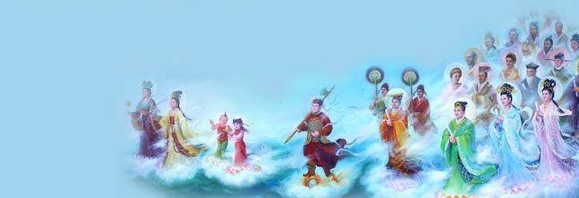

www.falunart.org

